Electrochemical Growth and Control of ZnO Dendritic Structures
Gao-Ren Li,*,†,‡ Xi-Hong Lu,† Dun-Lin Qu,† Chen-Zhong Yao,† Fu-lin Zheng,† Qiong Bu,† Ci-Ren Dawa,† and Ye-Xiang Tong*,†
MOE of Key Laboratory of Bioinorganic and Synthetic Chemistry, School of Chemistry and Chemical Engineering, Institute of Optoelectronic and Functional Composite Materials, Sun Yat-Sen UniVersity, Guangzhou 510275, People’s Replublic of China, and State Key Lab of Rare Earth Materials Chemistry and Applications, Beijing 100871, People’s Republic of China
ReceiVed: December 6, 2006; In Final Form: March 11, 2007
The dendritic crystal growth patterns that typically grow along principal crystallographic axes and have the hierarchical structure have been attracting much attention from scientists for several centuries. Here we report that the ZnO dendritic nanostructure as a new member of the ZnO family could be successfully prepared on Cu substrates by electrochemical deposition in the solution of ZnCl2 +citric acid at a temperature of 90 °C. Furthermore, our synthetic parameters allow further structural manipulation. The morphology evolvement from dendritic structures to nanorods could be successfully realized when KCl as supporting electrolyte was added to the deposition solution. The green light emission band of the ZnO dendritic structure prepared in
0.05 M ZnCl2 +0.05 M citric acid is almost negligible, indicating that these ZnO deposits are highly crystallized and of excellent optical quality. The PL spectra of the as-grown ZnO nanorods show they possess many oxygen vacancies, and the acquired ZnO nanorods have a potential application in sensors.

1. Introduction
Among the metal oxide semiconductors, ZnO with a wide band gap of about 3.4 eV and a large excitonic binding energy of about 60 meV at room temperature is probably one of the most attractive functional semiconductors because of its excel-lent chemical and thermal stability and its specific electrical and optoelectronic properties.1-5
The development of meso-or nanomaterials with special size and well-defined shape may open new opportunities for explor-ing material physical and chemical properties.6,7 In recent years semiconductor meso-and nanostructures have been attracting much attention due to their great potential for fundamental studies of the roles of dimensionality and size in their physical properties as well as for applications in optoelectronic nanode-vices and functional materials. There are many different nanostructures, such as nanobelts, nanorods, nanotubes, nanocubes, nanoplates, nanowires, of Group IV (such as Si and Ge), II-VI (such as ZnS and ZnSe), and III-V (such as GaAs and InP) semiconductors and oxides (such as ZnO, SnO2, GeO2, and SiO2), that have been successfully synthesized,8-15 and they have been demonstrated to have novel luminescent, electronic, optical, and mechanical properties.
Various methods have been developed for synthesizing different ZnO meso-and nanostructures, such as physical vapor deposition, chemical vapor deposition (CVD), electrochemical deposition, metalorganic vapor-phase epitaxy, metalorganic CVD, template-assisted growth, and various solution methods. Among these techniques, electrochemical deposition has shown a powerful ability to control the crystallization engineering of ZnO, and it presents a simple, quick, and economical method for the preparation of large area thin films, and has the advantage
* Address correspondence to these authors. E-mail: ligaoren@ mail.sysu.edu.cn (G.-R.L.); chedhx@mail.sysu.edu.cn (Y.-X.T.).
† Sun Yat-Sen University.
‡ State Key Lab of Rare Earth Materials Chemistry and Applications.
of allowing the controlled and patterned growth of nanostructures.16-20 The growth rate and surface morphology can easily be well controlled by deposition potentials, current densities, additive reagents and salt concentrations.
Among the different nanostructures, dendritic crystal growth patterns are attracting the attention of many scientists due to their importance connected to some fractal growth phenomena and crystallography research and because they have wide applications in micro-and nanodevices. The growth of dendritic crystals is also a profound example among a wide range of pattern-forming phenomena in nature and biology. In this paper, we first report on the electrochemical control growth of the shape and the orientation of crystallites of the ZnO dendritic structures by adding citric acid as a shape control agent without being template directed. Such dendrite structures are a type of higher level nanomaterials, and have an evident hierarchical structure.

2. Experimental Section
A simple three-electrode cell was used in our experiments. In electrochemical deposition, a graphite rod 4.0 cm2 was used as the auxiliary electrode, a saturated calomel electrode (SCE) was used as the reference electrode that was connected to the cell with a double salt bridge system, and a pure copper foil was used as the working electrode. Before deposition, the Cu foil was cleaned ultrasonically in 0.1 M HCl, distilled water, and acetone and then rinsed in distilled water again. Citric acid and KCl were added to the deposition baths to control the surface shapes of ZnO films. The electrochemical deposition of ZnO thin films was carried out under potentiostatic conditions with a deposition potential of -1.5 V on a Cu foil in ZnCl2 aqueous solutions at 90 °C. The energy dispersive spectroscopy (EDS), field emission scanning electron microscope (FE-SEM), and power X-ray diffractometry (XRD) were used to character-ize the obtained deposits, respectively. The photoluminescence

10.1021/jp068401+ CCC: $37.00 © xxxx American Chemical Society Published on Web 04/17/2007 PAGE EST: 5.2

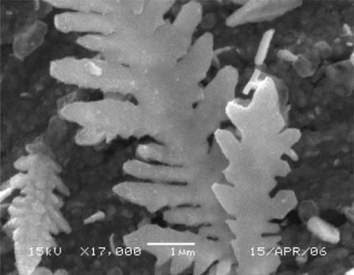
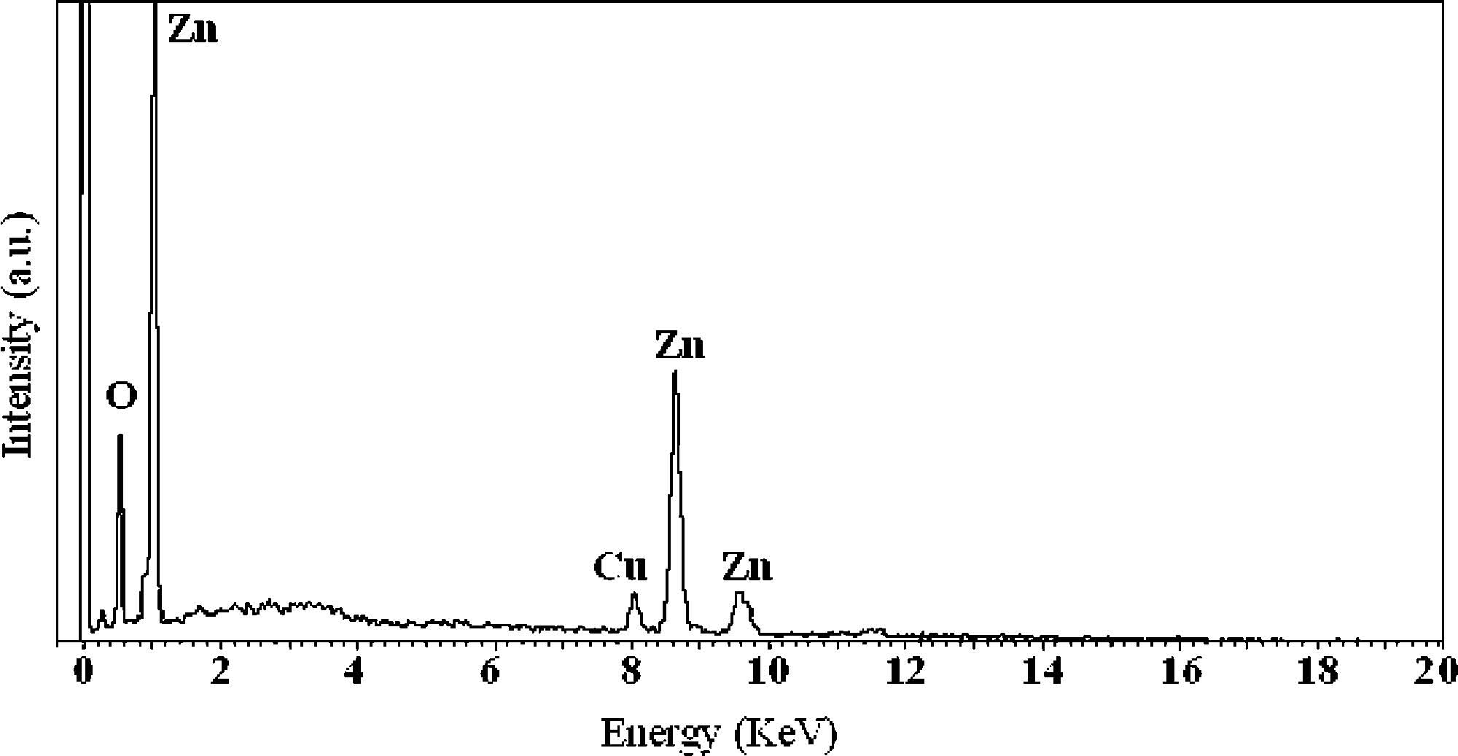
(PL) measurements were carried out on a fluorescence spec-trophotometer at room temperature, and the excited wavelength was 325 nm.

3. Results and Discussion
Potentiostatic electrolysis was carried out in a solution of
0.05 M ZnCl2 +0.05 M citric acid with a deposition potential of -1.5 V and an electrodeposition time of 90 min at 90 °C. Figure 1 shows a representative SEM image of the prepared ZnO sample. It can be clearly seen that the ZnO dendritic nanostructures that have a remarkable hierarchical structure were successfully synthesized, and the branches comprise numerous leaf-like platelets that connected with the stem. The shape of the ZnO dendritic structure is similar to the branch of a fern. The widths and lengths of these leaf-like platelets in the dendritic structures are in the range of 300-800 nm and 0.5-1.5 µm, respectively. The thickness of these plates is about 200 nm. The overall length of the ZnO dendritic structure is in the range of 6-10 µm depending on the synthetic conditions, and the stem is about 500-800 nm in diameter. The leaf-like platelets are well aligned on both sides of the stem. It is clear that the dendritic nanostructure is symmetric, and the angles between the stem and the branches are mostly about 40-50°. The EDS measurement was carried out at a number of locations through-out the prepared ZnO samples, and the representative EDS patterns are shown in Figure 2. An oxygen peak at 0.53 keV and Zn signals at 1.00, 8.63, and 9.58 keV can be observed. The copper peaks come form the substrate. The EDS results demonstrated that the prepared film was ZnO. The XRD patterns of the prepared films were shown in Figure 3, and the ZnO
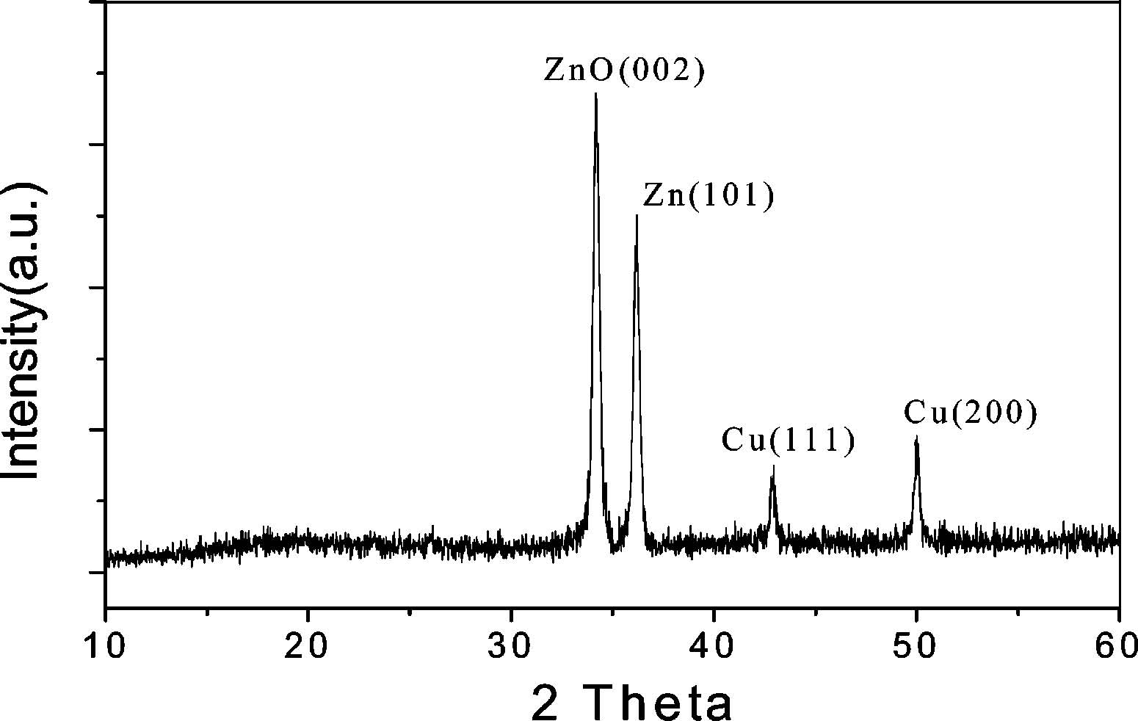
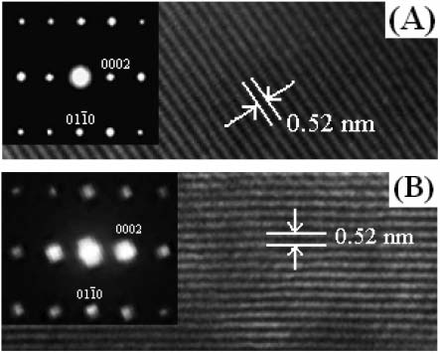
(002) and (101) peaks were observed. The results of XRD indicate that the obtained ZnO sample is a wurtzite structure (hexagonal phase, space group P63mc) according to JCPDS card No. 36-1451. The patterns of Cu(111) and Cu(200) were also observed in XRD, and they are according to the Cu substrate.
The products were further characterized by transmission electron microscopy (TEM). Figure 4A shows a representative high-resolution transmission electron microscopy (HRTEM) image recorded from the branch of the ZnO dendrite. The fringe spacing is determined to be 0.52 nm, which is close to the (0002) lattice spacing of ZnO. So the crystal growth of the branch is preferential in the (0002) direction. The HRTEM image taken from the trunk of the dendrite was shown in Figure 4B, which also shows the fringe spacing of about 0.52 nm. The HRTEM images of both the branch and trunk show that the individual ZnO dendrite is a single crystal and have identical crystal orientation. The ZnO dendrites were furthermore confirmed by selected area electron diffraction (SAED) measurements. The insets in panels A and B of Figure 4 show the SAED patterns taken from the branch and trunk, respectively. These SAED patterns also show that the ZnO dendrite is a single crystal, and the crystal growth of the branch and trunk are preferential in the (0002) direction.
The possible formation mechanism of the ZnO dendritic nanostructure can be depicted as follows. The joints of stem/ branch in Figure 1 with a fixed angle of 40-50° indicate that the growth is globally diffusion-controlled but locally ac-complished by oriented attachment.21 Penn and Banfield have recently found such oriented attachment to be responsible for the formation dislocations during early crystal growth.22 From the XRD patterns of ZnO dendritic structures, there are two

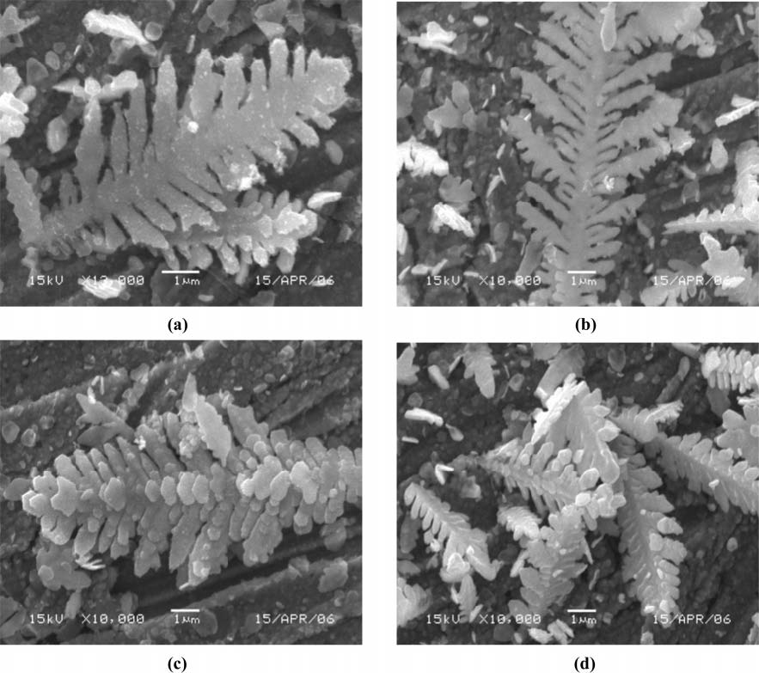
Figure 5. SEM images of ZnO dendritic mesostructures by electrodeposition in solutions of 0.05 M ZnCl2 +0.02 M citric acid (a), 0.05 M ZnCl2

different kinds of crystal growth directions observed, namely
(002) and (101). We should note that the angle between (002) and (101) is about 45°, which falls within the angle range of stem/branch. Therefore, the formation of the dendritic structure comes from the preferential growth along the (002) and (101) directions alternately in the successive branching generations.21 However, the angles between stem and branches are not exactly 45°, and therefore they are likely to be affected by the diffusion of ZnO precursors other than the crystal growth direction. During the electrochemical deposition experiments, the Zn atoms obtained were very active. When they encountered oxygen (dissolved in the solution), the oxidative-reductive reaction takes place and produces ZnO.23,24 The deposited metallic Zn can also be easily converted to ZnO via reacting with H2Oat high temperature (g90 °C), and H2 bubbles can be seen to leave the deposition solution.23-26 The deposited metallic Zn almost can completely convert to ZnO when the oxygenation rate of Zn is faster than the electrodeposition rate of Zn. However, the great mass of ZnO was converted from the deposited Zn by reacting with H2O because the dissolved oxygen in the deposi-tion solution was very limited. As H2 is released during the formation of ZnO, it provides an additional driving force for ZnO diffusion from the inner ZnO structures. Therefore, with the deposition time increasing, the dendritic structures with a fixed angle of stem/branch of 40-50° would be formed under the effect of the crystal growth direction and the diffusion of ZnO.
Our synthetic parameters allow further structural manipula-tion. Figure 5 displays some typical different ZnO crystals grown on the Cu substrates with different concentrations of citric acid. When the concentration of citric acid was 0.02 M in the deposition solution, the shapes of the leaf-like platelets in the deposited ZnO dendritic structures were spindly as shown in Figure 5a. When the concentration of citric acid was decreased to 0.01 M, the sizes of the leaf-like platelets in ZnO dendritic structures shown in Figure 5b were smaller, and most of them were acicular. Furthermore, we could observe that there were more branches in ZnO dendritic structures shown in Figure 5b than that shown in Figure 5a. It should also be noted that some subbranches were formed on the original branches. When a lower citric acid concentration was utilized and its concentration was 0.001 M in the deposition solution, the shapes of the branches were changed from leaf-like to rod-like as shown in Figure 5c. Also the number of the branches in the deposited ZnO greatly increased. The diameters of these rods were in the range of 300-500 nm and the lengths were about 1-2 µm. Simultaneously, a few small platelets were deposited on the surface of the central stem. The above phenomena could be explained as follows. The deposition rate of Zn was changed slowly because of the stabilizing role of citric acid for Zn(II) caused by complexing action when the citric acid was added to the solution of ZnCl2. The stabilizing role of citric acid for Zn-
(II) can be explained by the cyclic voltammograms measured in aqueous solutions of ZnCl2 and the mixture of ZnCl2 and

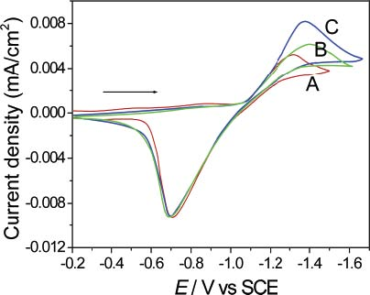
Figure 6. Cyclic voltammograms measured on Pt electrodes in the solutions of 0.05 M ZnCl2 (A), 0.05 M ZnCl2 +0.01 M citric acid (B), and 0.25 M ZnCl2 +0.01 M citric acid maintained at 90 °C. Scan rate, 100 mV/s.
citric acid (C4H6O6) (0.05 M ZnCl2 +0.01 M citric acid) at 90 °C as shown in Figure 6, panels A and B, respectively. The cathodic wave corresponding to the reduction of Zn(II) shown in Figure 6B shifted negatively compared with that shown in Figure 6A when both ZnCl2 and citric acid were present in solution. The cathodic shift suggests a restraining role of citric acid for the electroreduction of Zn(II). Therefore, with the decrease of the concentration of citric acid in solution, the electrodeposition rate of ZnO was increased and more nuclei were formed, which leads to the formation of more branches as shown in Figure 5b,c. Similar to those above synthesized at 90 °C, more ZnO dendritic structures could be obtained by increasing the concentration of ZnCl2 in the deposition bath, and Figure 5d shows the result when the electrodeposition was carried out in a solution of 0.25 M ZnCl2 +0.01 M citric acid. This phenomenon could also be explained by the cyclic voltammogram measured in a solution of 0.25 M ZnCl2 +
0.01 M citric acid. When the concentration of ZnCl2 was increased, the cathodic wave corresponding to the reduction of Zn(II) shown in Figure 6C shifted positively a little compared with that shown in Figure 6B, which indicates that the restraining role of citric acid for the electroreduction of Zn(II) shows a weak change. This may be caused by the concentration ratio of citric acid and ZnCl2 decreasing. The current density of the reduction peak potential of Zn(II) is also greatly increased. Therefore, with an increase in the concentration of ZnCl2 in the deposition solution, more ZnO dendritic structures will be formed.
When 0.1 M KCl was added to the above deposition solution, namely, ZnO films were electrodeposited in a solution of 0.25 M ZnCl2, 0.01 M citric acid, and 0.1 M KCl at 90 °C, typical SEM images of the obtained deposits were obtained and are shown in Figure 7. It could be clearly seen that ZnO dendritic structures disappeared, and the obtained ZnO products consist almost entirely of nanorods with diameters of about 100-150 nm. Figure 8 shows a typical transmission electron microscopy (TEM) image of an individual ZnO nanorod, and it reveals that the diameter of the deposited nanorod is about 125 nm. The electron diffraction pattern (the inset in Figure 8) shows (0001) as the growth direction for the nanorod. The presence of KCl as supporting electrolyte in the deposition solution has an important influence on both the nucleation rate and growth rate of ZnO. The electrochemical transfer of Zn2+ to cathode was increased when KCl was added to the deposition solution, which results in the explosive release of Zn2+ via the electroreduction process, and a large quantity of nucleates with
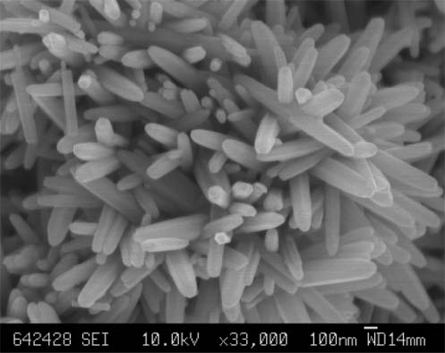
Figure 7. SEM image of ZnO nanorods fabricated via electrochemical deposition in a solution of 0.25 M ZnCl2 +0.1 M KCl +0.01 M citric acid.
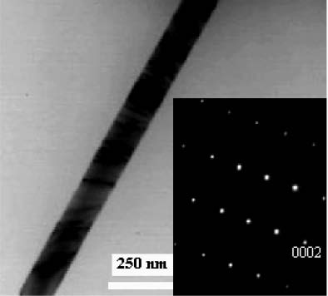
a small size were formed on the cathode. The directed aggregation growth mediated by the supporting electrolyte might occur. As we all know, there are two polar surfaces and six side facets in the hexagonal wurtzite ZnO, and they are generally bound by the (0001) and (101h0) families of planes, respectively. It is well-known that the growth rates of the different family of planes follow the sequence (0001) >(101h1) >(101h0) from the crystal habit of wurtzite ZnO.27 Although it has been demonstrated that adsorption of Cl-takes place preferentially onto the (0001) plane of ZnO and it is shows a preference to produce platelet-like or sheet-like crystals,28 the explosive release of Zn2+ was in favor of a linear aggregation of nucleates, and provided a favorable environment for the recrystallization into a single-crystalline structure along a (0001) orientation, namely the C axis, as the growth rate in the (0001) orientation is fastest in all the families of planes of ZnO, which leads to the formation of the individual well-separated and long nanorods as shown in Figure 7.
Photoluminescence (PL) properties of the different ZnO crystal patterns were further evaluated. Figure 9a shows the room temperature PL spectra of the branched mesostructures, which exhibit a relatively strong UV emission band and a weak green light emission band centered at about 385 and 500 nm, respectively. The room temperature PL spectrum of ZnO nanorods was shown in Figure 9b, and it exhibits a relatively weak UV emission band and a wide green light emission band. The UV emission originated from the excitonic recombination corresponding to the band edge emission of ZnO.29-31 The origin of the green luminescence from ZnO is associated with the intrinsic defect centers such as an oxygen vacancy, a zinc vacancy, interstitial zinc, interstitial oxygen, or antisite oxygen.29-31 However, there is still no consensus on the origin of this emission. The possibility that green emissions in different samples can have different origins despite a similar position and width has also been proposed.32 The PL spectra shown in Figure 9a reveal that the intensity of the green emission decreased with the addition of citric acid. Therefore, on the basis of these observations we can propose that the presence of the stronger green emission band in the PL spectra occurred when the synthesis was carried out in the lower concentration of citric acid, which could be attributed to the fast deposition rate. When the deposition of ZnO was carried out in the lower concentration of citric acid, the free Zn2+ ion concentration was higher, which leads to faster deposition, and many oxygen vacancies or interstitial Zn centers will be formed in the resulting ZnO crystal patterns. These defect centers acted as the origin of the green emission. This result indicated that one can regulate the surface morphology as well as the optical quality of ZnO branched mesostructures by using the proper amount of citric acid in the reaction medium. The green light emission band at around 500 nm related to oxygen vacancy in Figure 9a(i) is almost negligible, indicating that these ZnO electrodeposits are highly crystallized and of excellent optical quality. The PL spectrum in Figure 9b shows that the as-grown ZnO nanorods possess many oxygen vacancies. The oxygen vacancies are beneficial
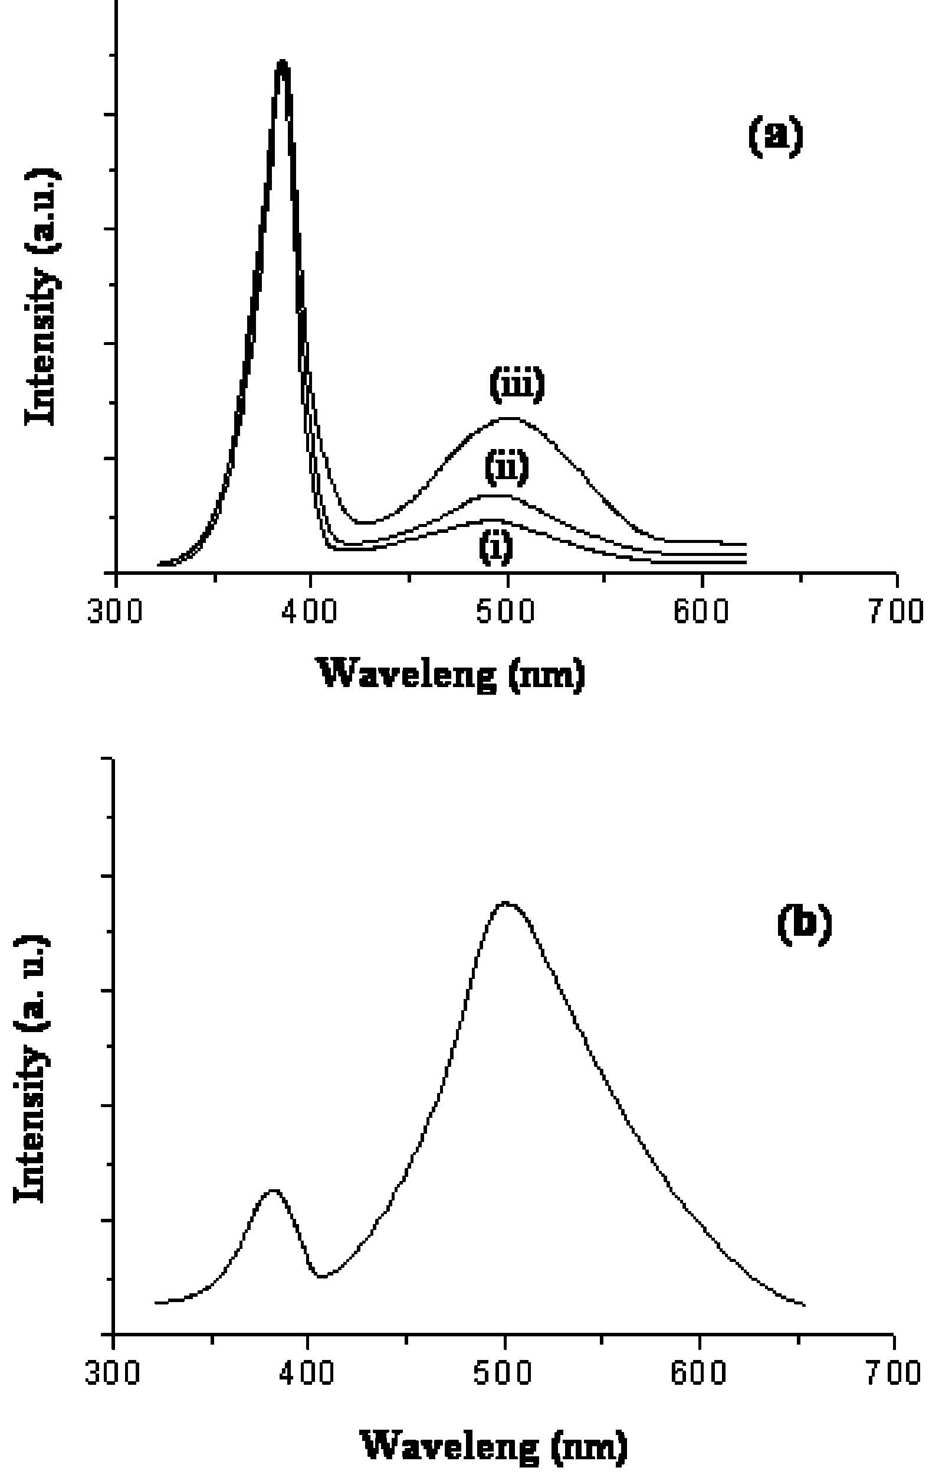
J. Phys. Chem. C E
to the sensitivity of the sensors. Thus the acquired ZnO nanorods are suitable for applications as sensors.

4. Conclusions
In summary, the dendritic crystal growth patterns that typically grow along principal crystallographic axes and have the hierarchical structure have been attracting much attention from scientists for several centuries. Here we first report the ZnO dendritic mesostructure as a new member of the ZnO family could be successfully prepared on Cu substrates by electrochemical depositon in a solution of ZnCl2 +citric acid at a temperature of 90 °C. Furthermore, our synthetic parameters allow further structural manipulation. By decreasing the con-centrations of citric acid, the size of the leaf-like platelets connected with the stem became smaller and smaller, and the number of leaf-like platelets became larger and larger. Also, the order of the arrangement of the leaf-like platelets became worse and worse with decreasing concentrations of citric acid. The morphology evolution from dendritic structures to nanorods could be successfully realized when KCl as the supporting electrolyte was added to the deposition solution. The green light emission band of the ZnO dendritic structure prepared in
0.05 M ZnCl2 +0.05 M citric acid is almost negligible, indicating that these ZnO deposits are highly crystallized and of excellent optical quality. The PL spectrum of the as-grown ZnO nanorods shows they possess many oxygen vacancies, and the acquired ZnO nanorods have a potential application in sensors. The unique synthetic mechanism of this approach is expected to generate different dendritic structure films of technological importance for other metallic and semiconducting materials.
Acknowledgment. The authors are grateful that this work was supported by the Natural Science Foundations of China (Grant Nos. 20603048 and 20573136), the Natural Science Foundations of Guangdong Province (Grant Nos. 06300070, 06023099, and 04205405), and the Foundations of Potentially Important Natural Science Research and Young Teacher Starting-up Research of Sun Yat-Sen University.

References and Notes
(1) Wang, Z. L.; Song, J. H. Science 2006, 312, 242.
- (2) Yu, H. D.; Zhang, Z. P.; Han, M. Y.; Hao, X. T.; Zhu, F. R. J. Am. Chem. Soc. 2005, 127, 2378-2379.
- (3) Choi, K. S.; Lichtenegger, H. C.; Stucky, G. D. J. Am. Chem. Soc. 2002, 124, 12402-12403.
- (4) Lao, C. S.; Liu, J.; Gao, P.; Zhang, L. Y.; Avidovic, D.; Tummala, R.; Wang, Z. L. Nano Lett. 2006, 263-266.
- (5) Sun, Y.; Fuge, G. M.; Fox, N. A.; Riley, D. J.; Ashfold, M. N. R. AdV. Mater. 2005, 17, 2477-2481.

(6) Cao, H. L.; Qian, X. F.; Wang, C.; Ma, X. D.; Yin, J.; Zhu, Z. K.
J. Am. Chem. Soc. 2005, 127, 16024-16025.
  - (7) MacLachlan, M. J.; Manners, I.; Ozin, G. A. AdV. Mater. 2000, 12, 675.
  - (8) Morales, A. M.; Lieber, C. M. Science 1998, 279, 208.
- (9) Huang, M. H.; Mao, S.; Feick, H.; Yan, H. Q.; Wu, Y. Y.; Kind, H.; Weber, E.; Russo, R.; Yang, P. D. Science 2001, 292, 1897.
  - (10) Wang, D. W.; Dai, H. J. Angew. Chem. 2002, 114, 4977; Angew. Chem., Int. Ed. 2002, 41, 4783.
  - (11) Duan, X. F.; Lieber, C. M. AdV. Mater. 2000, 12, 298.
  - (12) Huang, M. H.; Wu, Y. Y.; Feick, H.; Tran, N.; Weber, E.; Yang,

P. D. AdV. Mater. 2001, 13, 113.
- (13) Pan, Z. W.; Dai, Z. R.; Ma, C.; Wang, Z. L. J. Am. Chem. Soc. 2002, 124, 1817.
- (14) Gudiksen, M. S.; Wang, J. F.; Lieber, C. M. J. Phys. Chem. B 2001, 105, 4062.
- (15) Wang, Y. W.; Zhang, L. D.; Liao, C. H.; Wang, G. Z.; Peng, S. S. Chem. Phys. Lett. 2002, 357, 314.
- (16) Li, G. R.; Tong, Y. X.; Liu, G. K.; Kay, L. G. J. Phys. Chem. B 2006, 110, 8965-8970.

(17) Liu, R.; Vertegel, A. A.; Bohannan, E. W.; Sorenson, T. A.; Switzer,
J. A. Chem. Mater. 2001, 13, 508-512.
- (18) Li, G. R.; Kay, L. G.; Liu, G. K.; Tong, Y. X. J. Phys. Chem. B 2005, 109, 23300-23303.
- (19) Sander, M. S.; Gronsky, R.; Sands, T.; Stacy, A. M. Chem. Mater. 2003, 15, 335-339.
- (20) Prieto, A. L.; Martin-Gonzalez, M.; Keyani, J.; Gronsky, R.; Sands, T.; Stacy, A. M. J. Am. Chem. Soc. 2003, 125, 2388-2389.
  - (21) Wen, X.; Xie, Y.-T.; Mak, M. W. C.; Cheung, K. Y.; Li, X.-Y.; Renneberg, R.; Yang, S. Langmuir 2006, 22, 4836-4842.
  - (22) Penn, R. L.; Banfield, J. F. Science 1998, 281, 969.
- (23) Li, G.-R.; Dawa, C.-R.; Bu, Q.; Lu, X.-H.; Ke, Z.-H.; Hong, H.-E.; Zheng, F.-L.; Yao, C.-Z.; Liu, G.-K.; Tong, Y.-X. J. Phys. Chem. C 2007, 111, 1919-1923.
- (24) Li, G.-R.; Dawa, C.-R.; Bu Q.; Zheng, F.-L.; Lu, X.-H.; Ke, Z.-H.; Hong, H.-E.; Yao, C.-Z.; Liu, P.; Tong, Y.-X. Electrochem. Commun. 2007, 9, 863-868.

  - (25) Wang, J. G.; Tian, M. L.; Kumar, N.; Mallouk, T. E. Nano Lett. 2005, 1252.
  - (26) Beverskog, B.; Puigdomenech, I. Corros. Sci. 1997, 39, 107-114.
- (27) Kar, S.; Dev, A.; Chaudhuri, S. J. Phys. Chem. B 2006, 110, 17848-17853.
- (28) Xu, L.; Guo, Y.; Liao, Q.; Zhang, J.; Xu, D. J. Phys. Chem. B 2005, 109, 13519-13522.
- (29) Kar, S.; Dev, A.; Chaudhuri, S. J. Phys. Chem. B 2006, 110, 17848-17853.
- (30) Kar, S.; Pal, B. N.; Chaudhuri, S.; Chakravorty, D. J. Phys. Chem. B 2006, 110, 4605.
  - (31) Dev, A.; Kar, S.; Chakrabarty, S.; Chaudhuri, S. Nanotechnology 2006, 17, 1533.
  - (32) Tam, K. H.; Cheung, C. K.; Leung, Y. H.; Djurisic, A. B.; Ling,
- C. C.; Beling, C. D.; Fung, S.; Kwok, W. M.; Chan, W. K.; Phillips, D. L.; Ding, L.; Ge, W. K. J. Phys. Chem. B 2006, 110, 20865-20871.

