A Facile Hydrothermal Route to Synthesize 3D Whisk-broom-like Lanthanum Orthovanadate

Jianbo Tan, Jianxin Shi*, Jilin Zhang, Menglian Gong
School of Chemistry and Chemical Engineering, Sun Yat-Sen University,
Guangzhou 510275, People’s Republic of China
Abstract: Three-dimensional (3D) whisk-broom-like zircon-type lanthanum orthovanadate was synthesized by an ethylenediaminetetraacetic acid (EDTA)-mediated hydrothermal method. The products were characterized by using XRD, SEM, TEM and EDS. The experimental results showed that the morphology and microstructure of LaVO₄ nanocrystals were influenced by EDTA/La³⁺ ratio, reaction time, initial pH, vanadate source, and Na⁺ cation. A possible growth mechanism of 3D whisk-broom-like lanthanum orthovanadate was also proposed. The magnetic properties measurements showed that Neel temperature of the prepared whisk-broom-like t-LaVO₄ is higher than that of LaVO₄ nanorods.
Keywords: hydrothermal method; lanthanum orthovanadate; three – dimensional structure; magnetic properties

1. Introduction
Lanthanide orthovanadates have recently attracted much attention due to their unusual magnetic characteristics and useful luminescent properties.¹⁻⁸ And they can also be used as catalysts for the oxidative dehydrogenation of propane to propene.⁹ Lanthanide orthovanadates crystallize in two polymorphs of monoclinic (m-) monazite-type and tetragonal (t-) zircon-type. With increasing ionic radius, Ln³⁺ ions show a strong tendency toward monazite-structured orthovanadate due to its higher oxygen coordination number of 9 as compared with 8 of the zircon one. Therefore, the thermodynamically stable state is monazite-type for lanthanum orthovanadate (LaVO₄), while zircon-type for the other orthovanadates.⁹ The zircon-type orthovanadates have much better magnetic and luminescent properties than the monazite-type.^{3-5, 9} The monazite-type LaVO₄ can be synthesized through the hydrothermal or mechanochemical reaction.^{3, 9, 10} Because of its metastability, zircon-type LaVO₄ can be only synthesized with the hydrothermal method, such as ethylenediaminetetraacetic acid (EDTA)-mediated,^{1, 2, 9} the selected-control synthesis by tuning the pH values of the solution,^{3, 4} and also the microemulsion-mediated.¹¹
Because of its size- and shape-dependent optical, electronic and magnetic properties, much effort has been made to control the morphology of LaVO₄.^{1, 9} The morphology strongly lies on the initial conditions, such as the pH,³⁻⁵ the lanthanum sources,³ and the additions such as EDTA, DTPA (Diethylenetriaminepentacetic acid) and CyDTA (trans-1, 2-Diaminocyclohexane - N, N, N’, N’- tetraacetic acid hydrate).^{1, 9} One-dimensional (1D) structures like nanorod, nanowire and nanotube of LaVO₄ have been synthesized through the hydrothermal reaction under different conditions.^{1-5, 9, 11} Much effort has also been focused on preparing other materials with 3D structures, such as octahedral molecular sieves,¹² tin dioxide,¹³ zinc oxide ¹⁴ and titanate.¹⁵ However, to the best of our knowledge, there has been no paper reporting on the synthesis of LaVO₄ with 3D structure. Herein, we demonstrated a facile hydrothermal route to synthesize 3D whisk-broom-like t-LaVO₄. The effects of EDTA/La³⁺ ratio, reaction time, initial pH, vanadate source, and Na⁺ cation on the morphology of the prepared t-LaVO₄ were studied. A possible growth mechanism was also proposed.

2. Experimental Section
2.1. Preparation. All of chemical regents used in the experiments were of analytical grade without further purification. The zircon-type LaVO₄ was synthesized by using the EDTA-mediated hydrothermal method. In a typical synthesis procedure, 4.00 mL of 0.40 mol/L La(NO₃)₃ solution (dissolved from La₂O₃ by HNO₃) and appropriate EDTA with the EDTA/La³⁺ molar ratios of 0.20, 1.00 or 1.25, respectively, were mixed in a teflon-lined stainless autoclave of 50 mL capacity under constant magnetic stirring for 10 min. Then 0.0016 mol NH₄VO₃ was mixed with the solution and it turned into yellow suspension immediately. After stirred for another 5 min, 2 mol/L NaOH solution was added dropwise with stirring to adjust the pH value to 9.50, and the suspension turned into solution. Finally, the solution was diluted with deionized water to fill up to 70% of the total volume. The autoclave was sealed and heated in an oven at 180 ℃ for 24 h, and then allowed to cool down to room temperature naturally. The precipitated white powders were separated by centrifugation, washed with deionized water for several times, and then dried in a vacuum oven at 70 ℃ for 24 h. Under the similar hydrothermal procedure with the EDTA/La³⁺ ratio of 1.25, t-LaVO₄ samples were obtained with various reaction time while the initial pH was 9.50, and also with different initial pH values while the reaction time was 48 h. Furthermore, a series of samples were prepared with higher EDTA/La³⁺ ratios while the initial pH was 9.50 and the reaction time was 48 h.
2.2. Measurements. The X-ray powder diffraction (XRD) patterns of the samples were collected with a Rigaku D/max-2200 X-ray diffractometer using Cu Kα radiation (λ = 0.15406 nm) operating at 40 kV and 30 mA. The scanning electronic microscopy (SEM) and energy-dispersive X-ray spectroscopy (EDS) of the samples were obtained by the thermal field emission environmental SEM-EDS-ERSD (Model: Quanta 400F). Transmission electron microscope (TEM) and high-resolution transmission electron microscope (HRTEM) observations were carried out on a JEM-2010HR instrument operated at 200 kV combined with a fast two-dimensional Fourier transform (FFT) analysis technical. The magnetic properties of the sample were measured with a Quantum Design MPMS XL-7 SQUID magnetometer in the temperature range of 5~300 K.

3. Results and Discussion

3.1. Synthesis and characterization of t-LaVO₄.
Figure 1. XRD patterns of t-LaVO₄ obtained with different EDTA/La³⁺ ratios. (a) 0.20; (b) 1.00; (c) 1.25.
The yields of the samples obtained with the EDTA-mediated hydrothermal method are more than 45%. The phase and purity of the samples are determined by the XRD measurements. The XRD patterns of the products obtained for the EDTA/La³⁺ ratios of 0.20, 1.00 and 1.25 are shown in Figure 1. All the diffraction peaks could be readily indexed to the pure tetragonal zircon-type LaVO₄ (JCPDS 32-0504), and no other impurities have been found. The XRD results of the samples prepared with the other conditions reveal that they are all the pure phase of t-LaVO₄.
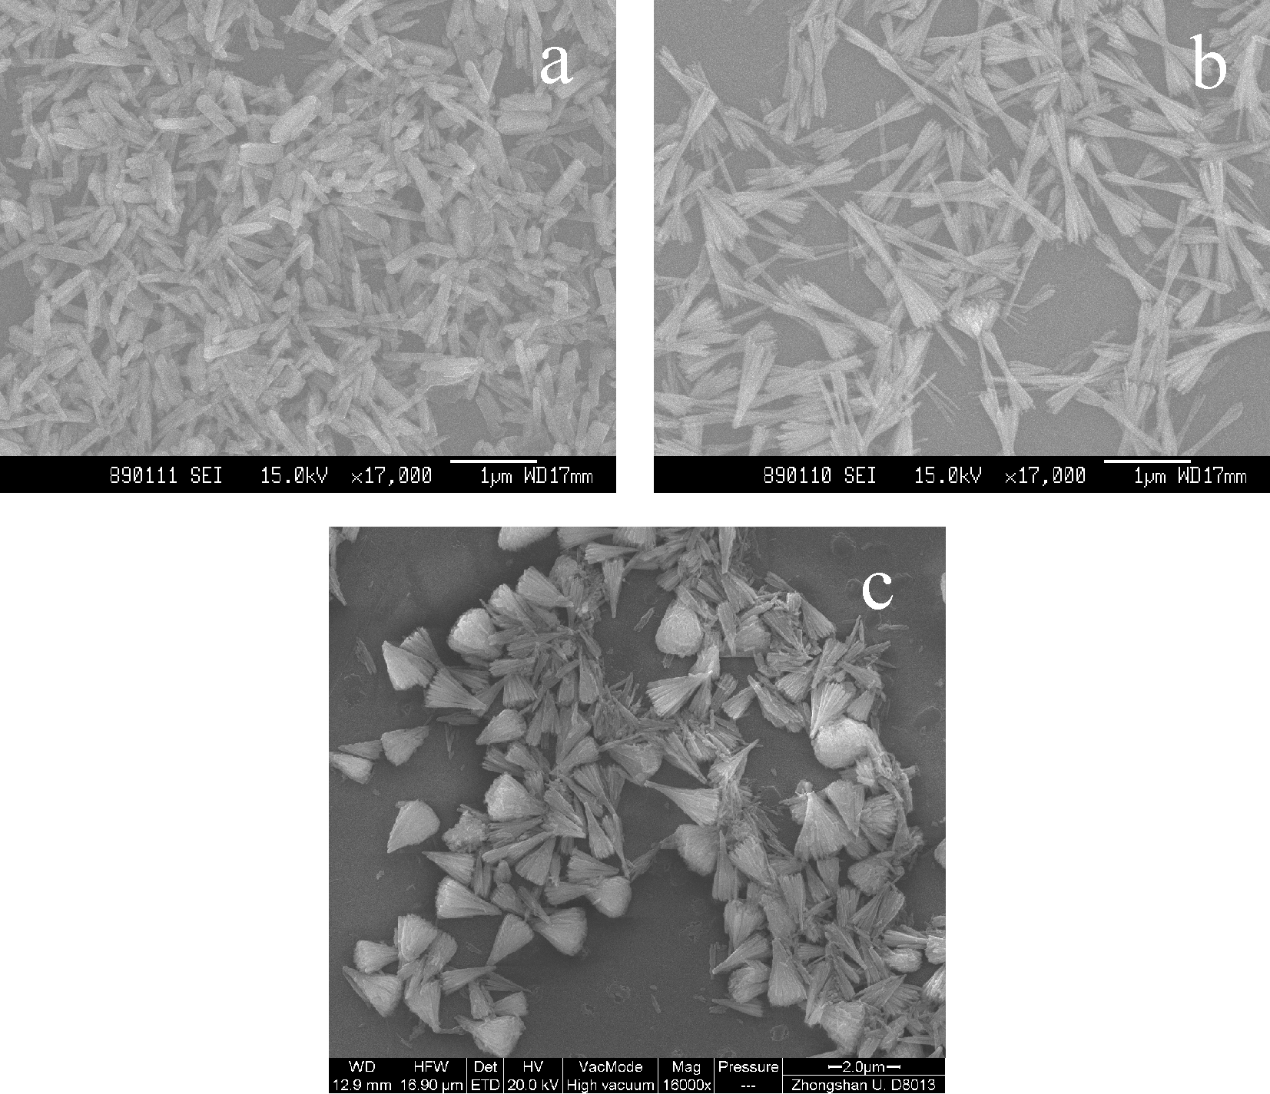
Figure 2. SEM images of t-LaVO₄ obtained with different EDTA/La³⁺ ratios. (a) 0.20; (b) 1.00; (c) 1.25.
The SEM images of the samples obtained for different EDTA/La³⁺ ratios are shown in Figure 2. We can see that, when the ratio is 0.20 (Figure 2a), only rod-like t-LaVO₄ is formed with the diameter of 90~190 nm and the length of about 500 nm. And when the ratio is 1.00 (Figure 2b), the main morphology is rod-like with splitting at both sides of the rods, but the splitting is still at the primary stage. As the ratio is further increased to 1.25 (Figure 2c), only the whisk-broom-like exists. It is obviously that the ratio of EDTA/La³⁺ plays an important role in controlling the morphology and microstructure of t-LaVO₄ products.
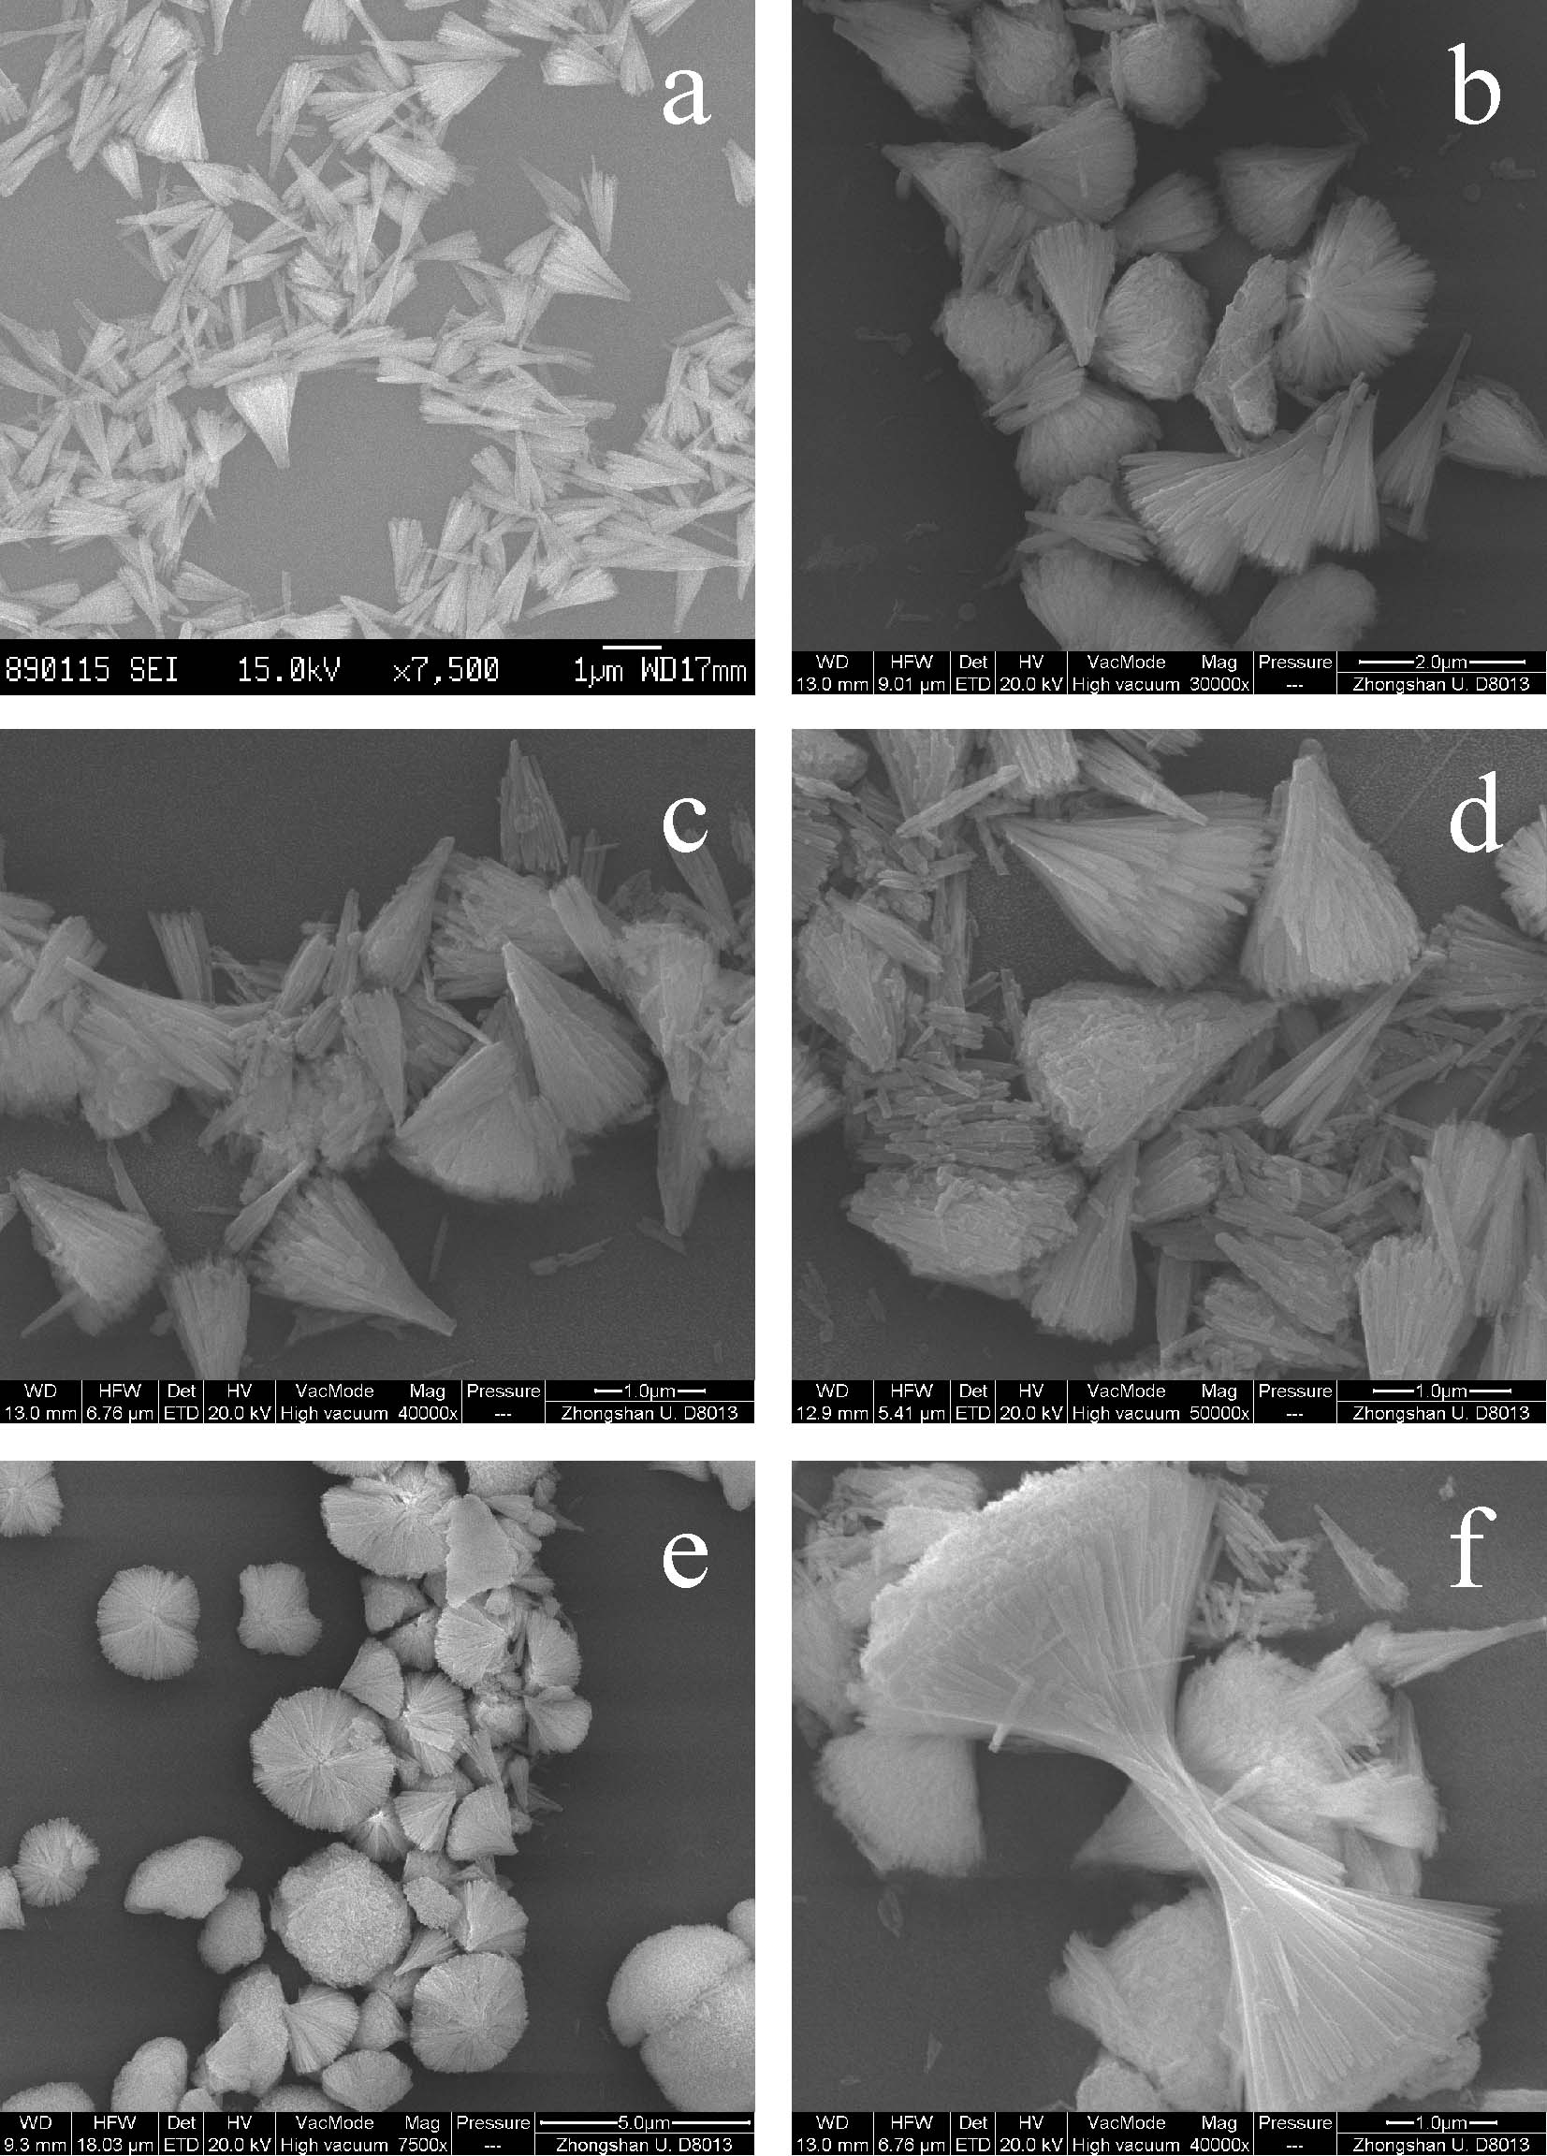
Figure 3. SEM images of t-LaVO₄ obtained under different reaction time. (a) 2; (b) 6; (c) 12; (d) 24; (e) 48; (f) 60 h.
The effect of the hydrothermal reaction time on the morphology of t-LaVO₄ has also been studied in the present work. From the SEM images in Figure 3, we can see that the products are mainly whisk-broom-like. The 3D whisk-brooms become larger and larger with increasing the time from 2 h (Figure 3a) to 24 h (Figure 3d). When the time is prolonged to 48 h (Figure 3e), some hemisphere shapes appear. As further increasing the time to 60 h (Figure 3f), a few asymmetrical dumbbell-like shapes exist.
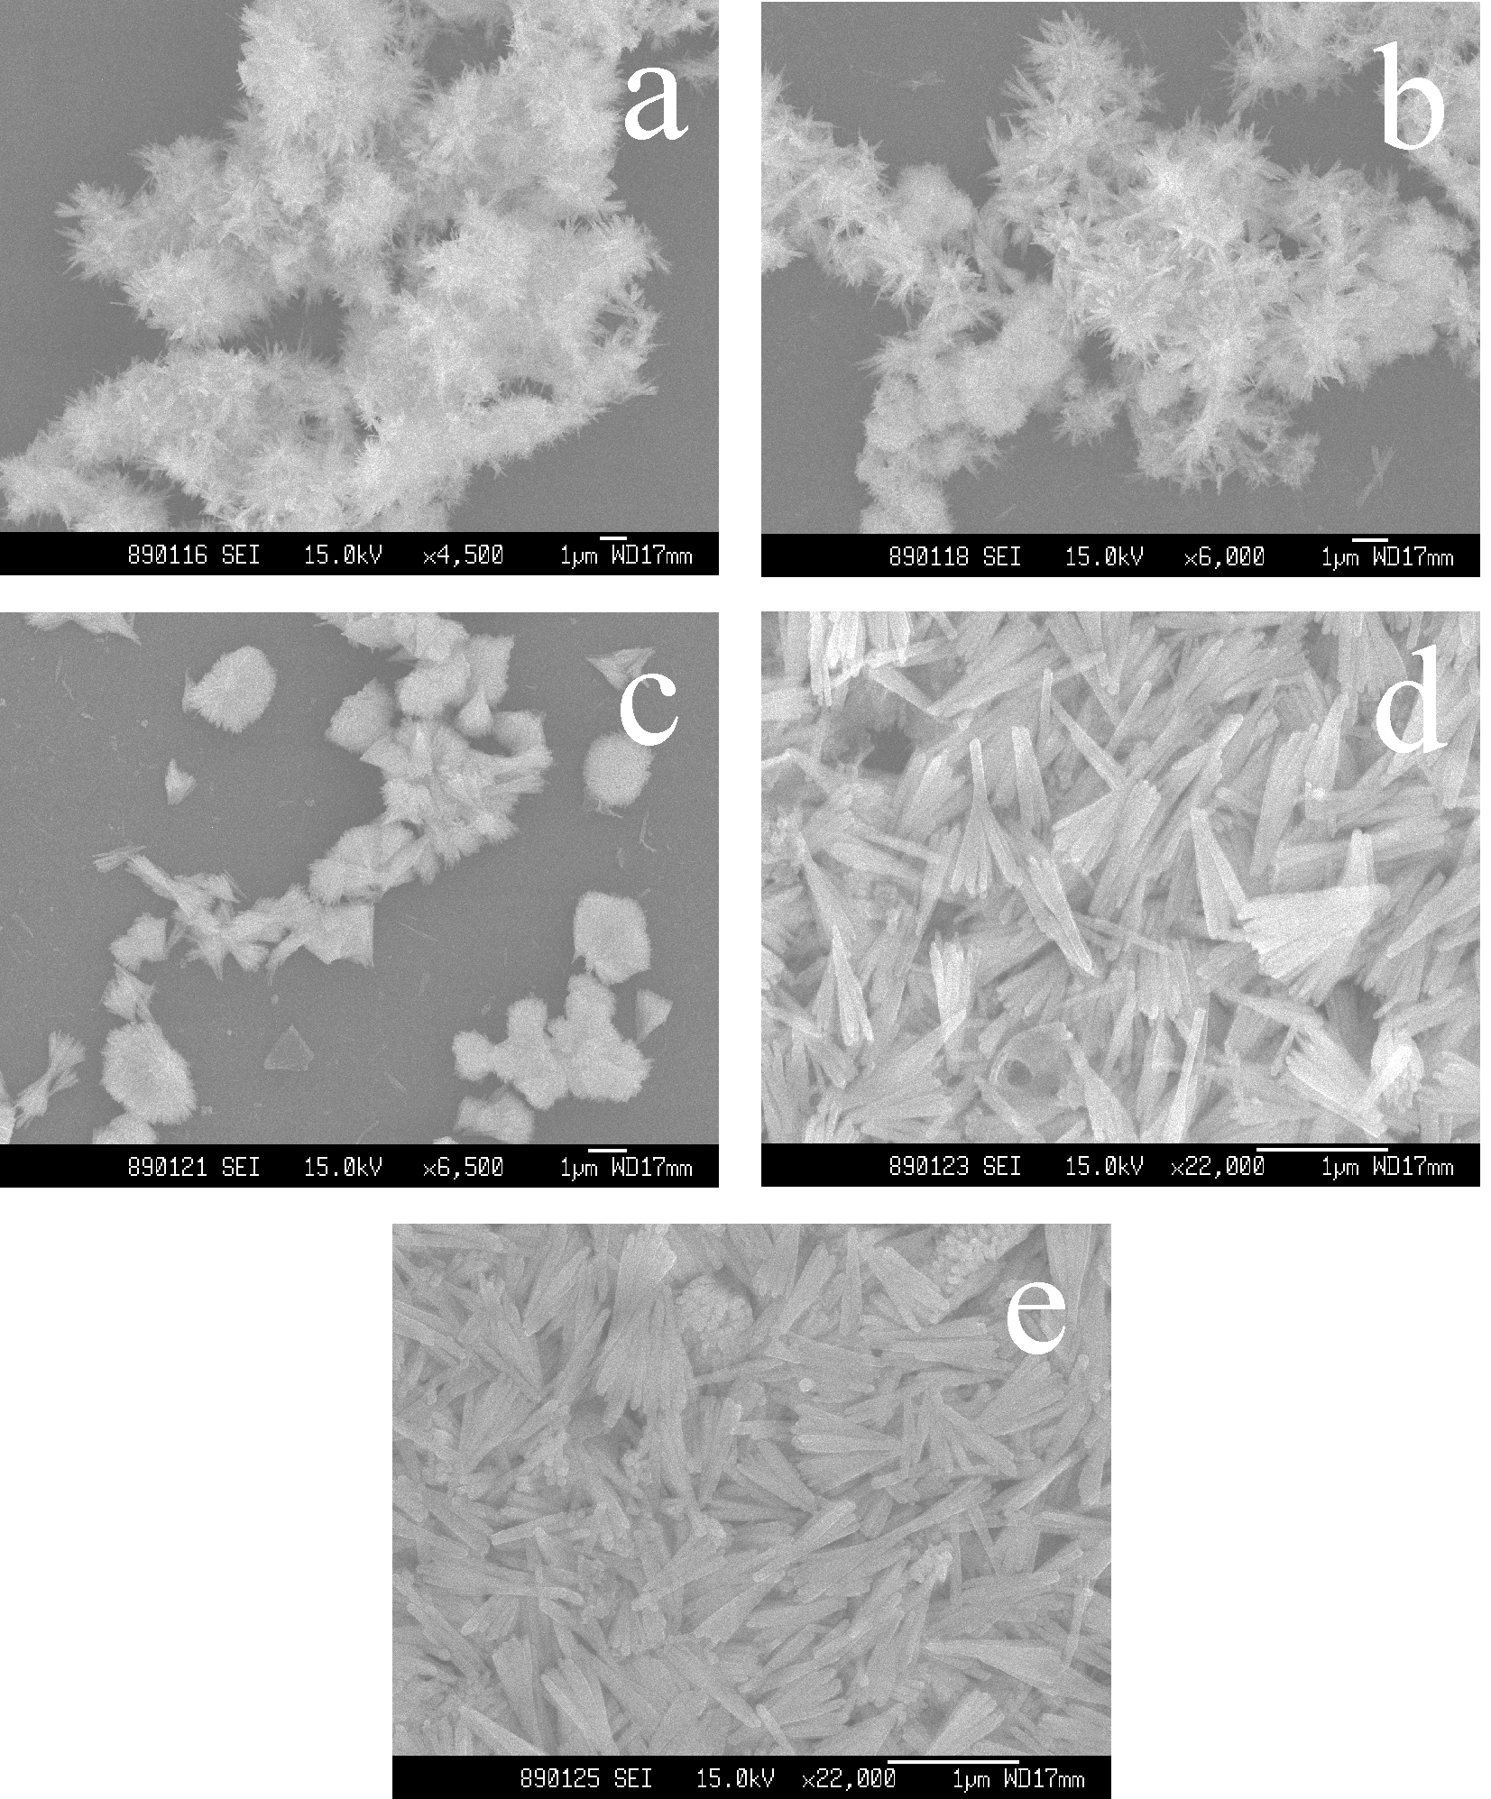
Figure 4. SEM images of t-LaVO₄ obtained under different initial pH values. (a) 5.00; (b) 6.00; (c) 7.00; (d) 8.00; (e) 9.00.
The morphology of t-LaVO₄ is still evidently affected by the initial pH value of the solution. Figure 4 shows the SEM images of the samples synthesized at different initial pH values. Prickly spheres are formed under the pH of 5.00 (Figure 4a). With increasing the pH to 6.00, the plum-like shells and prickly spheres appear at the same time (Figure 4b). Only plum-like shells exist with further increasing the pH to 7.00 (Figure 4c). When the pH values are greater than 7, the products are composed of the nanorods splitting at one side (Figure 4d and e). But the splitting is still at the initial stage. The results that the morphology of the as-prepared t-LaVO₄ changed with the initial pH values can be explained with the facts that the chelation ability of EDTA with metal ions is affected by the pH value. EDTA can chelated with La³⁺ best at the solution of pH = 9.5.¹ When the pH is smaller than 8, EDTA chelateds with La³⁺ inadequately, and then the prepared t-LaVO₄ samples are the prickly spheres. While the pH is higher than 8，the chelation ability of EDTA is enhanced, so the samples are nanorods with splitting only at one side. When the pH is increased to 9.5, the 3D whisk-brooms with adequately splitting are formed.
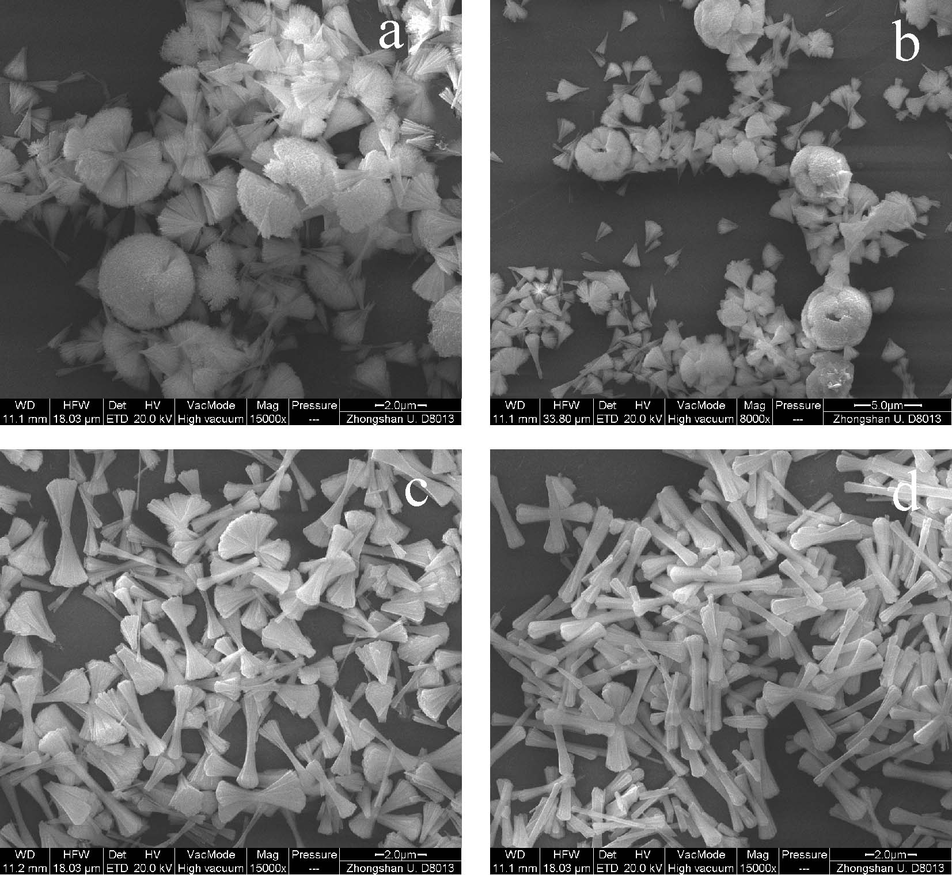
Figure 5. SEM images of t-LaVO₄ obtained with different EDTA/La³⁺ ratios. (a) 1.25; (b) 1.50; (c) 2.00; (d) 2.50.
To the best of our knowledge, there is no article presented using large amount of EDTA (the ratio of EDTA/La³⁺ > 1.25) to synthesize t-LaVO₄. Figure 5 shows the morphology of t-LaVO₄ synthesized with EDTA/La³⁺ ratios of 1.25, 1.50, 2.00 and 2.50, the initial pH of 9.50 and the reaction time of 48 h. When the ratio is 1.25 (Figure 5a), the products are mainly whisk-broom-like. With the ratio increasing, the whisk-broom-like is decreasing, while the dumbbell-like gradually becomes the major. In this series, the branches of the dumbbell-like are larger than that synthesized with the condition of EDTA/La³⁺ ratio is 1.0 (Figure 2b).
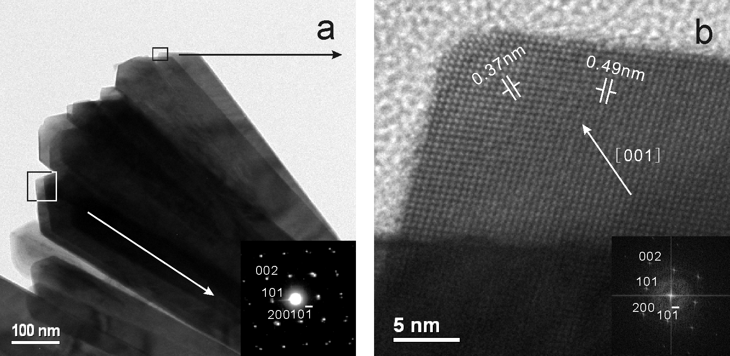
Figure 6. TEM and HRTEM images of whisk-broom-like t-LaVO₄.
Figure 6 shows the TEM and HRTEM images of whisk-broom-like t-LaVO₄. From the image of Figure 6a, we can see that the whisk-broom is formed by the rectangle-like sheets. In Figure 6b, the interplanar spacing of 0.37 nm and 0.49 nm is close to the d₂₀₀ (0.374 nm) and d₁₀₁ (0.495 nm) of t-LaVO₄, respectively. The electron diffractions show that the whisk-broom-like t-LaVO₄ is of high crystallinity with the tetragonal crystal-phase and the whisk-broom growth is along with the [001] direction.
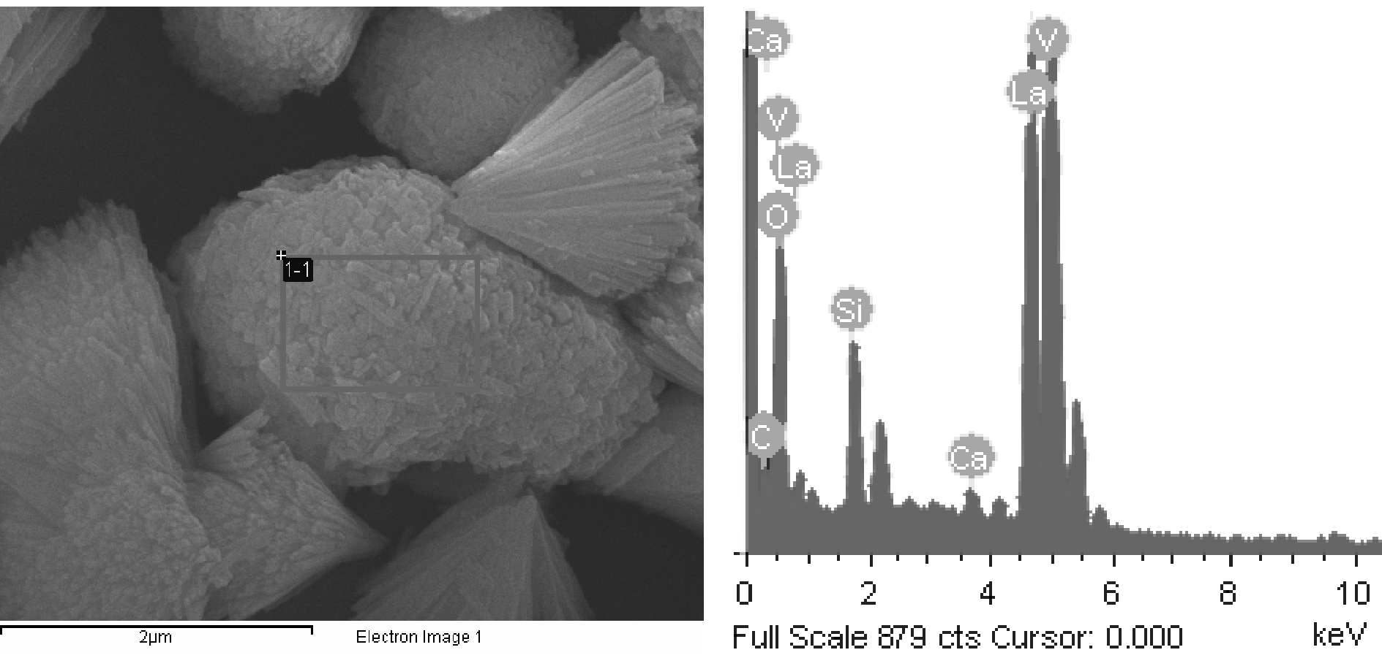
Figure 7. EDS pattern of the t-LaVO₄ sample prepared with the EDTA/La³⁺ ratio of 1.25, the initial pH of 9.50, and the reaction time of 48 h.
The EDS pattern of the t-LaVO₄ sample, obtained with the ratio of 1.25, the pH of 9.50 and the reaction time of 48 h, is shown in Figure 7. It reveals that the ratio of La/V is close to 1. The C peak comes from the carbon in organic compounds. The Si and Ca peaks come from the glass used as the carriers for the measurement.
3.2. Growth mechanism of 3D whisk-broom-like t-LaVO₄.
According to the results of XRD, SEM, TEM and EDS, the growth mechanism of the whisk-broom-like t-LaVO₄ in the present hydrothermal process is proposed as follows. Crystal splitting may occur due to several reasons, and it has not been completely understood. However, generally speaking, splitting is associated with fast crystal growth. With other conditions being the same, crystal growth depends strongly on the solution oversaturation.¹⁶ Other factors that have been found to cause crystal splitting are mechanical splitting, that is when extra molecules appear in some layers of its crystallographic network, and chemical splitting, that is when certain ions(e.g., Mg²⁺ and Ca²⁺) are present in the parent solution.¹⁷
By using similar EDTA-mediated hydrothermal method, Nian Wang et al.^{1, 2} and Chun-Jiang Jia et al.⁹ have used Na₃VO₄ as vanadate source to synthesize t-LaVO₄ nanorods. Herein, we used NH₄VO₃ as the vanadate source. So we think that the vanadate source is a key factor to cause the crystal splitting. And the morphology is certainly the results of the cooperative effects of the vanadate source with the other factors. The detail effect of the vanadate source on the morphology of t-LaVO₄ is under research.
Jang-Hoon Ha and his co-workers have found that Na⁺ cation affects the nanostructure obtained under the hydrothermal condition.¹⁸ In another experiment, when we used NH₃·H₂O instead of NaOH to adjust the pH value, we can not get pure t-LaVO₄. So Na⁺ is also a crucial factor to the forming of 3D whisk-broom-like t-LaVO₄.
EDTA plays an important role in the forming process of the whisk-broom-like shape. The effects of EDTA toward the morphology have been proposed above. Only when the amount of EDTA is sufficient, the splitting occurs. Nian Wang et al. have used EDTA as the chelate ligand and structure-directing template to synthesize the t-LaVO₄ nanorods.¹ With the appropriate effects, EDTA has the ability of limiting the growth rate of different facets distinguishingly, leading to the seeming restriction of crystal growth.⁶
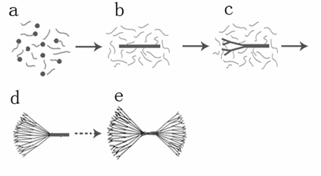
Figure 8. Schematic illustration of the formation process of the whisk-broom-like t-LaVO₄.
The possible formation mechanism of hierarchical t-LaVO₄ nanocrystals can be shown as Figure 8. Under the condition of pH = 9.50, no visible deposit existed until the reaction time reached 2 h. When the hydrothermal reaction time is very short, small particles are formed and surrounded by the EDTA molecules,⁹ just like Figure 8a. As the reaction time is increased, nanorods are formed in the presence of EDTA (Figure 8b). Then the branching of the nanorods appears which is caused by the cooperative effects of the pH, the EDTA/La³⁺ ratio, NH₄VO₃ and Na⁺. Due to the chelation ability of EDTA, only one side of the nanorods splits, and the whisk-broom-like is formed, the same as Figure 8c and d. When the reaction time is long enough, the chelation ability of EDTA is weakened. So EDTA cannot restrict the growth of t-LaVO₄. The nanorods can also split at another side, and the dumbbell-like is formed (Figure 8e). Since the occurred time of the splitting at the both sides of the nanorods is not the same, the dumbbell-like will not be symmetrical, just like the image of Figure 3f.
3.3. Magnetic properties of t-LaVO₄.
Figure 9. The relationship between the temperature and the magnetic susceptibility of the whisk-broom-like t-LaVO₄.
Figure 9 presents magnetization as a function of temperature for the whisk-broom-like t-LaVO₄ obtained with the EDTA/La³⁺ ratio of 1.25, the initial pH of 9.50 and the reaction time of 48 h. The magnetic susceptibility (χ_{M}) measurement is performed in the temperature range of 5~300 K under 1000 Oe in the field cooling (FC) process. We can see that, upon field cooling, whisk-broom-like t-LaVO₄ exhibits antiferromagnetic behavior in a certain temperature range, just as the prediction according to Anderson Mediate Exchange Model. Neel temperature (T_{N}) of the whisk-broom-like t-LaVO₄ is about 130 K, which is much higher than that of LaVO₄ nanorods (T_{N} ≈ 55 K).¹ Above T_{N}, χ_{M} decreases with increasing temperature, which means that the whisk-broom-like t-LaVO₄ behaves as a paramagnetic state due to the existence of La³⁺.

4. Conclusions
A facile hydrothermal route has been demonstrated to synthesize 3D whisk-broom-like zircon-type lanthanum orthovanadate, and the possible formation mechanism of hierarchical nanocrystal has also been discussed. In this case, the reaction time, the initial pH, the EDTA/La³⁺ ratio, the vanadate source, and Na⁺ cation influence the morphology of the prepared t-LaVO₄. The results of magnetic properties show that Neel temperature of the prepared whisk-broom-like t-LaVO₄ is higher than that of LaVO₄ nanorods. We believe that the present study will enlarge the 3D nanomaterial family. Further work is under way to explore the potential properties and the controlling factors for this unusual kind of morphology, and to better understand the exact mechanism of the crystal growth.
References
(1) Nian Wang; Quanfei Zhang; Wen Chen, Cryst. Res. Technol. 2007, 42, 138.
(2) Nian Wang; Wen Chen; Quanfei Zhang; Ying Dai, Mater. Lett. 2008, 62, 109.
(3) Weiliu Fan; Xinyu Song; YuXiang Bu; Sixiu Sun; Xian Zhao, J. Phys. Chem. B 2006, 110, 23247.
(4) Weiliu Fan; Wei Zhao; Liping You; Xinyu Song; Weimin Zhang; Haiyun Yu; Sixiu Sun, J. Solid State Chem. 2004, 177, 4399.
(5) Weiliu Fan; Yuxiang Bu; Xinyu Song; Sixiu Sun; Xian Zhao, Cryst. Growth Des. 2007, 7, 2361.
(6) Feng Luo; Chun-Jiang Jia; Wei Song; Li-Ping You; Chun-Hua Yan, Cryst. Growth Des. 2005, 5, 137.
(7) Cuicui Yu; Min Yu; Chunxia Li; Cuimiao Zhang; Piaoping Yang; Jun Lin, Cryst. Growth Des. 2009, 9, 783.
(8) Qian LW; Zhu J; Chen Z; Gui YC; Gong Q; Yuan YP; Zai JT; Qian XF, Chem. Eur. J. 2009, 15, 1233.
(9) Chun-Jiang Jia; Ling-Dong Sun; Li-Ping You; Xiao-Cheng Jiang; Feng Luo; Yu-Cheng Pang; Chun-Hua Yan, J. Phys. Chem. B 2005, 109, 3284.
(10) Takatoshi Tojo; Qiwu Zhang; Fumio Saito, J. Alloy Compd. 2007, 427, 219.
(11) Weiliu Fan; Xinyu Song; Sixiu Sun; Xian Zhao, J. Solid State Chem. 2007, 180, 284.
(12) Wei-Na Li;, Jikang Yuan; Xiong-Fei Shen; Sinue Gomez-Mower; Lin-Ping Xu, Adv. Funct. Mater. 2006, 16, 1247.
(13) Haizhen Wang; Jianbo Liang; Hai Fan; Baojuan Xi; Maofeng Zhang; Shenlin Xiong; Yongchun Zhu; Yitai Qian, J. Solid State Chem. 2008, 181, 122.
(14) Yajuan Sun; Yue Chen; Lijin Tian; Yi Yu; Xianggui Kong; Qinghui Zeng; Youlin Zhang; Hong Zhang, J. Lumin. 2008, 128, 15.
(15) Yuanbing Mao; Mandakini Kanungo; Tirandai Hemraj-Benny; Stanislaus S. Wong, J. Phys. Chem. B 2006, 110, 702.
(16) Jing Tang; A. Paul Alivisatos, Nano Lett. 2006, 6, 2701.
(17) Grigor'ev, D. P. Ontogeny of Minerals; Israel Program for Scientific Translations: Jerusalem, 1965.
(18) Jang-Hoon Ha; P. Muralidharan; Do Kyung Kim, J. Alloy. Compd. 2008 doi:10.1016/j-jallcom.2008.07.048.

特殊形貌三维钒酸镧的水热合成及表征
谭剑波 石建新* 张吉林 龚孟濂
中山大学化学与化学工程学院无机所 广州 510275
摘要：以EDTA模板导向剂，采用水热法合成了三维扫把状四方锆石型钒酸镧。通过XRD、SEM和EDS对产物进行了表征。实验结果表明，LaVO₄纳米晶的形貌受EDTA / La³⁺比例、反应时间、初始pH、钒源和钠离子等因素影响。在此基础上，提出了三维扫把状四方锆石型钒酸镧的形成机理。磁性测试结果显示，三维扫把状四方锆石型钒酸镧的尼耳温度比钒酸镧纳米棒的高。
关键词：水热法，钒酸镧，三维纳米结构，磁性

中山大学化学与化学工程学院第九届创新化学实验与研究基金项目 第一作者：谭剑波，男，中山大学化学与化学工程学院，2005级，化学生物学专业 指导老师：石建新 副教授 Email: cessjx@mail.sysu.edu.cn

