Improving electrochemical performance of polyaniline by introducing carbon aerogel as filler
Fei Xu^{a,b}, Gengdong Zheng ª, Dingcai Wu^{a,b*}, Yeru Liangª, Zhenghui Liª, Ruowen Fu^{a,b*}

- Materials Science Institute, PCFM Laboratory, School of Chemistry and Chemical Engineering, Sun Yat-sen University, Guangzhou 510275, P. R China
- DSAPM Laboratory, Chemical Engineering, Sun Yat-sen University, Guangzhou 510275, P. R China
Email: wudc@mail.sysu.edu.cn, cesfrw@mail.sysu.edu.cn.
Abstract: Polyaniline (PANI) with carbon aerogel (CA) as conducting filler was synthesized by an in-situ chemical oxidative polymerization method. Scanning electron microscopy, infrared spectra, cyclic voltammetry and X-ray diffraction indicated that the three-dimensional carbon nano-network of CA was entirely buried inside PANI matrix and its introduction basically did not change the structure of PANI. The electrochemical performances of the as-prepared PANI materials with CA filler were evaluated by means of galvanostatic charge-discharge tests, cyclic voltammetry and electrochemical impedance spectroscopy. It was found that the electrochemical performances of PANI were notably improved due to the introduction of CA filler. For example, when operating at a large current density of 50 mA/cm², CA-modified PANI with the optimal CA/aniline ratio of 1.0 wt.% exhibits a specific capacitance as high as 226 F/g, whereas PANI without CA has only 89 F/g. The CA modification mechanism of PANI has been discussed in detail.

Introduction
Since the rediscovery of the conducting properties in the early 1980s, polyaniline has generated extensive interest in many potential applications including light emitting diodes, chemical sensors, anti-corrosion coatings, batteries, and capacitors [1]. As a conducting polymer, polyaniline is regarded as one of the most promising electrode materials for pseudo-capacitors, resulting from its high chemical durability, ease of synthesis and reversible control of conductivity both by protonation and by charge-transfer doping. However, PANI used as electrode material has two main disadvantages: (1) the shrinkage and swelling of PANI chains during the doping/dedoping process, resulting in deteriorating of capacitance; (2) the occurrence of the insulating state during charge-discharge process, leading to high resistivity and poor power-output [2,3]. Scientists have overcome these defects effectively by introducing carbon nanotubes (CNT) as filler into PANI matrix [3,4]. As we known CA is of unique three-dimensional carbon nano-network with high electrical conductivity. Moreover, the ambient pressure drying preparation of CAs has provided chances for mass production with an appropriately low cost [5]. Therefore, we believe that the electrochemical performance of PANI will be greatly improved if such a nanocarbon material is introduced as novel filler into PANI matrix.
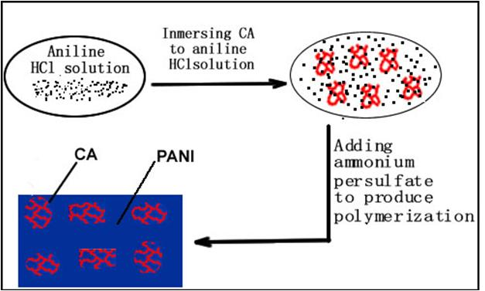
Fig. 1 Schematic illustration of the procedure for preparing CA modified PANI.

We report herein the fabrication of CA-modified PANI by an in situ chemical oxidative polymerization in presence of CA (shown in Fig.1). CA with various contents was added to aniline of HCl solution and then ammonium persulfate of HCl solution was added dropwise to produce polymerization at ice bath. Finally, the as-prepared products were filtered, washed with copious water and then vacuum dried. The samples are denoted as PANI-CAxx, where xx represents the mass ratio of CA to aniline. For blank test, pure PANI without CA was prepared using the same procedure. As highlighted here, the electrochemical performance, especially at high current density, of PANI can be greatly improved by only adding a dab of CA (i.e., 1.0 wt.% of CA/ANI mass ratio) because of the introduction of unique three-dimensional carbon nano-network into PANI matrix.

Results and discussions
The electrochemical performances were executed by assembling the symmetric two-cell sandwich-type supercapacitor. The electrolyte was 1 M H₂SO₄. Figure 2 shows the specific capacitances (C_{m}) of all samples subjecting to various current densities. First of all, we found that CA content plays a very important role in the capacitance of PANI/CA composites, especially at high current densities; and 1.0 wt.% of CA content has a best modification effect, judging from the fact that the maximum capacitance always occurs when selecting such a CA amount, no matter the current density. Furthermore, it should be noted that all PANI/CA composites have a higher capacitance than pure PANI without CA at various current densities.
Fig.2. Effect of CA content on specific capacitance of PANI/CA composites. | Fig.3. Capacitance retention rates as a function of the current densities for CA, PANI, and PANI-CA1.0.
The corresponding relationship between the C_{m} retention ratio and the current density is also plotted in Figure 3. As expected, CA has a basically invariable C_{m} in the current density of 5 ~ 50 mA/cm² because of its perfect electrical conductivity; whereas due to high electrical resistance of unmodified PANI matrix, the C_{m} of pure PANI dramatically decreases from 323 to 89 F/g at the same current density range and a C_{m} retention ratio as low as 27.6 % is obtained at 50 mA/cm². However, when introducing 1.0 wt.% of CA filler into PANI matrix, the as-prepared PANI-CA1.0 has a significantly improved C_{m} retention ratio (i.e., 62.8 %) at such a high current density. Taken together, these results demonstrate that PANI-CA1.0 has superior electrochemical performance as well as better suitability for large current operation compared to unmodified PANI.
To understand the mechanism of the above enhanced electrochemical performances of CA-modified PANI, we investigated the structural differences of PANI between the unmodified PANI and the optimum CA-modified sample PANI-CA1.0, because it has been suggested that a slight structural changes may result in considerable changes in their conductivity values [6].
First of all, there is no obvious morphological difference between PANI with and without CA filler, as shown SEM images in Figure 4. This point demonstrates that the carbon nano-networks of CA were completely buried inside PANI matrix after the in-situ polymerization. Furthermore, these two samples seem to have a very similar infrared spectrum (shown in Figure 5). As for pure PANI, the characteristic peaks at 1477 and 1567 cm⁻¹ are assigned to the benzene ring and the quinoid ring, respectively. The peaks at 1294, 1109 and 791 cm⁻¹ are in accordance with literature ever reported for PANI [7, 8]. Recent advances in developing PANI composites with CNT as filler suggest that the graphitic and π-bonded surface of CNT can interact strongly with the quinoid rings via π-stacking. As a result, composite exhibits a larger 1600/1500 cm⁻¹ intensity ratio compared with that of pure PANI in FTIR spectrum [8]. In our case, the 1600/1500 cm⁻¹ intensity ratio of PANI and PANI-CA1.0 is very close (0.84 and 0.82 for the former and the latter, respectively), most likely due to the fact that the sp³ hybrid carbon for amorphous CA could not function like sp² carbon for CNT via π-stacking.

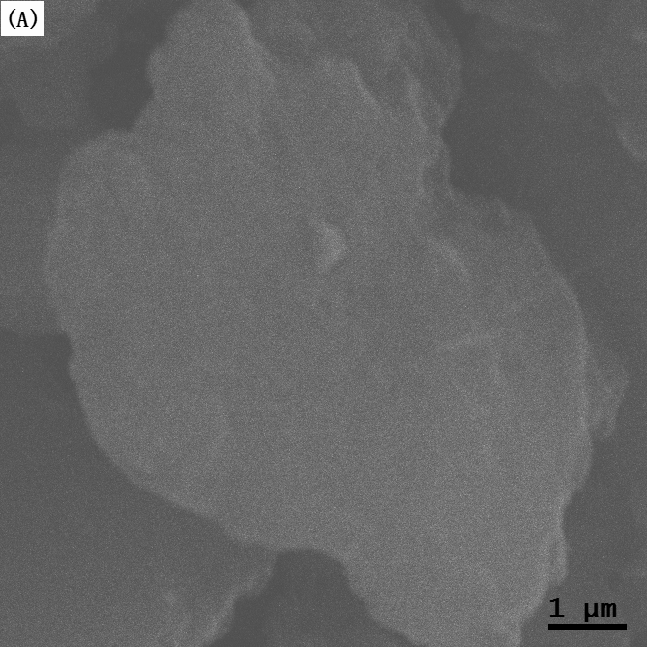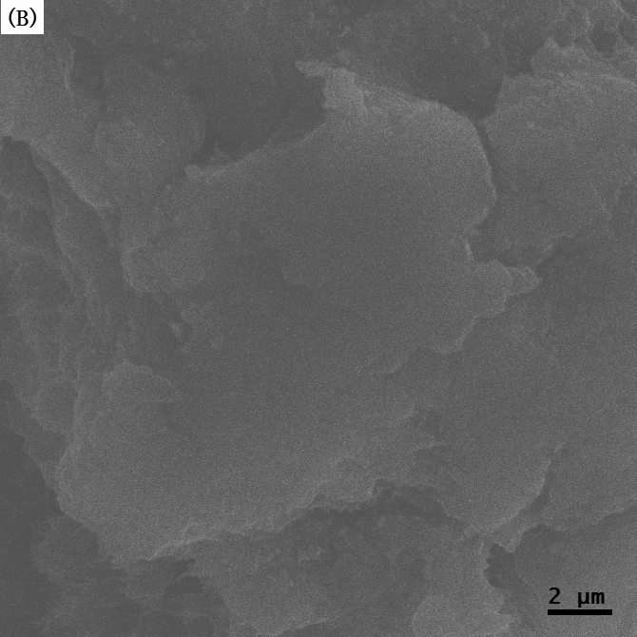
Fig. 4. SEM photographs of PANI (A) and PANI-CA1.0 (B).
Fig. 5. FTIR spectra of PANI and PANI-CA1.0. | Fig.6. CV curves of PANI and PANI-CA1.0 at 2 mV/s.
This unchangeable chemical structure of PANI after the introduction of CA filler can also be supported by cyclic voltammetry (CV) (seen in Figure 6). The CVs for both PANI and PANI-CA1.0 have a couple of peaks (i.e., oxidation and reduction peaks) and their peak positions are very close to each other, demonstrating that the two samples have almost the same PANI chemical structure. Moreover, we found the XRD patterns for both of them are highly similar, as shown in Figure 7. This observation reveals that the crystalline property of PANI retains regardless of introduction of CA filler.
These above experimental results show that the CA filler buried inside PANI matrix basically does not change PANI’s chemical structure and crystalline property under our experimental conditions. As a result, we believe that CA filler just serves as conducting pathway in the PANI/CA composites, thus leading to the improvement of the electrochemical properties of PANI matrix. This point can be validated by the qualitative CV observation and quantitative EIS analysis.

Fig. 7. XRD patterns of PANI and PANI-CA1.0. | Fig. 8. Nyquist plots in the range of 10 k to 10 mHz for PANI and PANI-CA1.0. The inset shows the expanded high-frequency region of the plots.

Generally, the Current/Potential slope at the switching potentials in CV can be used to qualitatively reflect a magnitude of the active electrode material’s conductivity [9]. Here, we found that at the switching potential of 0.6 V, a larger slope occurs for PANI-CA1.0, demonstrating PANI-CA1.0 is of a quicker current response and thus has better electric conductivity as compared to the unmodified PANI. Such a conductivity difference can be further revealed by EIS characterization, as shown in Figure 8. It is known that the intensity of semicircle in the high-frequency region of Nyquist plots can be used to estimate the intrinsic resistance of active electrode materials, considering the fact that both the electrolyte and cell-assembling technique are the same [9, 10]. Based up this, we found that the intrinsic resistance of the pure PANI is as high as 963 mΩ; whereas that of the CA-modified PANI-CA1.0 is only 95 mΩ, because the presence of the unique three-dimensional carbon nano-network of CA filler promotes the charge transfer of PANI matrix.
Conclusions
CA-modified PANI materials have been successfully prepared by an in-situ chemical oxidative polymerization method. The three-dimensional carbon nano-network of CA filler buried inside PANI matrix seemed to have no effect on PANI’s structure but has been proven to act as conducting pathway, thereby improving the electrochemical properties of the PANI matrix. The optimal use amount (i.e., CA/ANI mass ratio) of CA filler was determined to be 1.0 wt.%. As a result, the as-prepared CA-modified PANI materials have higher capacitance at various current densities as well as better capacitance retention ratio with increasing the current density as compared to the pure PANI without CA filler.

Acknowledgements
This research was supported by the ninth of Innovative chemical experiment and research Fund.
References:
[1] A.G. MacDiarmid, Angew. Chem. Int. Ed. 40(2001)2581.
[2] V. Khomenko, E. Frackowiak, F. Béguin, Electrochim. Acta 50 (2005) 2499.
[3] Y.K. Zhou, B.L. He, H.L. Li, Electrochim. Acta 49 (2004) 257.
[4 ] S.R. Sivakkumar, W.J. Kim, D.W. Kim, J. Power Sources 171 (2007) 1062.
[5] D.C. Wu, R.W. Fu, G. Dresselhaus, Carbon 44 (2006) 675.
[6] P. Dallas, D. Stamopoulos, N. Boukos, et al, Polymer 48 (2007) 3162.
[7] L.X. Li, H.H. Song, J. Power Sources 187 (2009) 268.
[8] H. Zengin, W.S. Zhou, J.Y. Jin, Adv. Mater. 14 (2002) 1480.
[9] K.H. An, W.S. Kim, Y.S. Park, et al, Adv. Funct. Mater. 11(2001) 387.
[10] D. Hulicova, M. Kodama, H. Hatori, Chem. Matter. 18 ( 2006) 2318.

炭气凝胶填料改善聚苯胺的电化学性能
徐飞, 郑耿东, 吴丁财*，梁业如，李争辉，符若文*
聚合物复合材料及功能材料教育部重点实验室，中山大学化学与化学工程学院，广州 510275
摘要：本论文通过原位化学氧化聚合的方法将CA作为填料引入到PANI基体中，以期改善PANI的电化学特性。SEM、FTIR、XRD和CV等测试结果表明：CA的三维网络骨架全部被埋覆在PANI基体中，并且它的引入不会改变PANI的化学结构和微晶结构。PVI、EIS和CV等电化学测试结果表明：CA填料对PANI有明显的改性效果，其最佳用量（CA与苯胺的质量比）为1.0 wt.%。例如，在50 mA/cm2的大电流充放电条件下，PANI的比电容仅为89 F/g，当引入1.0 wt.%填料进行改性后，其比电容剧增至226 F/g。CA的改性机理在于：充放电过程中，炭纳米网络骨架在PANI基体中起到三维导电通道的作用，从而赋予PANI优异的电化学性能。
关键词：聚苯胺，炭气凝胶，原位化学聚合，电化学性能，超级电容器

