Ordered Mesoporous Carbon with Good Mass Transport: Nanostructure Design, Preparation and Application in Supercapacitors

Yeru Liangª, Dingcai Wuª, and Ruowen Fu^{a,b*}

a) Materials Science Institute, PCFM laboratory, School of Chemistry and Chemical Engnieering, Sun Yat-sen University, Guangzhou, 510275, P. R. China
b) Institute of Optoelectronic and Functional Composite Materials

Abstract: Activated ordered mesoporous carbons with channel structure (AOMCs-CS) were successfully prepared by imposing CO₂ activation on ordered mesopore carbon C-FDU-15. It is found that even at a very high burn-off level, e.g. 73 wt%, due to the existence of the continuous carbon framework, the basic hexagonal mesostructure of C-FDU-15 can still be found and many larger mesopores and macropores are generated in the AOMCs-CS. The electrochemical performances indicate that the mass specific capacitance and resistance continuously increase with the burn-off increasing. Even possessing the biggest resistance after the intense activation treatment, unlike other activated carbons, AOMCs-CS73 shows an ascending electric double layer specific capacitance (C_{edl}), where interconnected channels and large pores play an important role to meet the needs of good mass transport for improving pore utilization rate effectively.

Keywords：Ordered mesoporous carbon; Activation; Good mass transport; Supercapacitors.

1. Introduction

Developing high performance power sources is one of the most important tasks in the world. Due to the increasing demand for electrical energy with high specific power and long durability, supercapacitors, which are considered to be novel energy storage units, have been extensively studied recently.1-3 The popularity of this storage device is derived from its higher energy density relative to conventional capacitors and longer cycle life and higher power density relative to batteries.⁴ So supercapacitors can be equipped for hybrid vehicles, digital telecommunication systems and other devices that need high-pulse discharge profile.⁵ During the charging process, the electric double layer is formed at the electrode/electrolyte interface where charges are accumulated on the electrode surfaces and ions of opposite charge compensate them in the electrolyte side.⁶⁻⁷ Hence, an optimal electrode material requires a well tailored nanostructure carbon of high surface for charge accumulation and interconnected mesopores/macropores for quick mass transportation.⁸⁻⁹
As a class of novel porous carbons, ordered mesoporous carbons (OMC) have attracted considerable attention for their remarkable properties (e.g. regular mesopore arrangement, narrow pore distribution). Mass transfer is excellent in the tunnel-like mesopore of OMC with hexagonal plane group symmetry. However, for the unconnected channel structure, the mass transport has a bad performance between the mesotunnels and limit the transfer or diffusing of ions. Additionally, compared with commercially activated carbons, OMC have fewer micropores which are the crucial places to storage energy, and it is rather limited for higher supercapacitors performance. So, it remains a challenge to design and build OMC materials and many efforts have been made to provide insight into how to design the nanostructure. As one of such efforts, activation has proved to be very effective in improving the porous structure. For example, the activation of CMK-3 has been reported by Gao and co-works and the as-prepared activated CMK-3 had an obviously better H₂ sorption capacity than the precursor CMK-3.10 In addition, it has been shown that the ordered mesoporous structure of activated CMK-3 gradually became disorder and then changed into a thoroughly disordered wormlike pore structure when prolonging the activation time.¹⁰
Unlike ordered mesoporous carbon CMK-3 constructed with an ordered array of carbon nanorods or nanowires with reverse structure of the template SBA-15,11 ordered mesoporous carbons with channel structure (AOMCs-CS) such as C-FDU-15 have an ordered hexagonal mesostructure which is the same as that of the SBA-15. As a result of such a structural difference, C-FDU-15 has proved in the research of Zhao and co-workers to have a higher mechanical stability than CMK-3, likely due to its continuous carbon framework.¹² Similarly, we believe that such a continuous carbon framework will help to keep the basic 2-D hexagonal mesostructure when imposing an intense activation on the ordered mesoporous carbons. On the other hand, such activation will enrich the micropores and generate larger pores between the neighboring channels for good mass transport meanwhile. In this paper, C-FDU-15 was prepared and then was activated. On the basis of investigating pore structure change of the resulting AOMCs-CS during the activation treatment in detail by XRD, TEM and N₂ adsorption, their supercapacitors properties were compared in order to find out the relationship between structure and electrochemical performance.

2. Experimental

2.1. Sample preparation. The precursor ordered mesoporous carbon C-FDU-15 was prepared as reported in the literatures.¹² The C-FDU-15 was heated with a heating rate of 10 ℃/min to 900 ℃under N₂ flow and then activated with 20 ml/min CO₂ for a predetermined activation time. As a result, activated ordered mesoporous carbons with channel structure were obtained, which were denoted as AOMC-CSxx, where xx denote the burn-off.
2.2. Porous Structure Characterization. Low-angle XRD patterns were recorded on a D-MAX 2200 VPC diffractometer using Cu Kα radiation (40 kV, 30 mA). TEM images were obtained by a JEM-2010HR microscope. Samples for TEM measurements were dissolved in ethanol by an ultrasonicator and then supported on a carbon-coated copper grid. N₂ adsorption measurements were carried out using a Micromeritics ASAP 2010 analyzer at 77K. Before measurements, the samples were degassed at 250 ℃ for more than 10h. The BET surface area (S_{BET}) was analyzed by Brunauer-Emmett-Teller (BET) theory. The total pore volume (V_{t}) was estimated from the amount adsorbed at a relative pressure P/P₀ of 0.990. The mesopore volume (V_{mes}) and average mesopore diameter (D_{mes}) were derived from the adsorption branch using Barrett-Johner-Halendar (BJH) theory combined with Kruk-Jaroniec-Sayari correction.¹³ The extent surface area (S_{ext}), micropore volume (V_{mic}) and micropore surface area (S_{mic}) was determined by t-plot theory. The pore size distribution was analyzed by original density functional theory (DFT) combined with non-negative regularization and medium smoothing.
2.3. Electrochemical Measurements. The measurement samples were prepared by mixing AOMCs-CS and polytetrafluorethylene (PTFE) together in the ratio of 92:8, and then rolling the mixture into a film with a roller, cutting the film into a suitable shape and covering a 1 by 1cm plain nickel foam (current collector) with the film, and finally pressing the ensemble together under about 2 MPa. Electrochemical measurements (cyclic voltammetry (CV) and AC impedance) were carried out at room temperature using a 30% KOH aqueous solution as an electrolyte, and using an IM6e Electrochemical Workstation with a typical three-electrode configuration. In CV measurement, the potential scan rates were set as 10 to 100 mV/s. In AC impedance measurement, the range of frequency was set to go between 10⁻²Hz and10⁴Hz.

3. Results and Discussion

3.1 Pore characteristics of AOMCs-CS. The X-ray diffraction (XRD) pattern for the precursor C-FDU-15 in Figure 1 shows an intense diffraction peak (10) and two resolved diffraction peaks (11) and (20), indicating that the as-prepared C-FDU-15 has a 2-D hexagonal mesostructure.¹³ Furthermore, ordered straight channels can be visibly observed in the TEM images of C-FDU-15 (See Figure 2 (A)). These results show that C-FDU-15 prepared here is a typical ordered mesoporous carbon with channel structure (OMC-CS). When imposing 3h of CO₂ activation treatment on the C-FDU-15, the resulting AOMC-CS, i.e. AOMC-CS31, has a burn-off of 31wt%. It can be seen that the XRD pattern (Figure 1) and the TEM image (Figure 2) of AOMC-CS31 are very like those of its precursor,
Figure 1. XRD patterns of the precursor C-FDU-15 and related activated ordered mesoporous carbons with channel structure with various burn-offs

indicating that such a burn-off hardly destroys the order degree of the resulting AOMC-CS. When further increasing the burn-off by prolonging the activation time, the order degree of the resulting AOMCs-CS, e.g. AOMC-CS65 and AOMC-CS73, gradually becomes lower, judging from the decreasing intensity and increasing width of the XRD peaks with the burn-off in Figure 1. However, even at a very high burn-off level, e.g. 73wt%, the diffraction peaks (10) still keeps resolved, although the diffraction peaks (11) and (20) have disappeared. This clearly shows that even when imposing such an intense activation treatment, the basic ordered mesostructure of the precursor can still be found in the resulting products, e.g. AOMC-CS73. Such a decreasing order degree with increasing the burn-off from 31 to 73 wt% can also be vividly observed by the comparison of the TEM images of the three AOMCs-CS AOMC-CS31 (Figure 2(B)), AOMC-CS65 (Figure 2(C)) and AOMC-CS73 (Figure 2(D)). When increasing the burn-off from 31to 65wt%, more and more carbon walls are punched and thus many neighboring channels are interconnected (see Figure 2(B) and (C)). Furthermore, as the burn-off continuously increases to 73wt%, the punching action from activation becomes very intense and partial carbon frameworks thoroughly collapse (see Figure 2(D)). As a result, more and more disorder structure can be found in the samples with an increase in the burn-off, and larger mesopores and macropores (see Figure 2(D)) can be generated in the samples with high burn-offs, e.g. AOMC-CS73. It should be noted that the formation of these interconnected channels and large pores by the activation treatment will help to meet the needs of rapid mass transport for many applications such as separation, catalysis and energy storage.

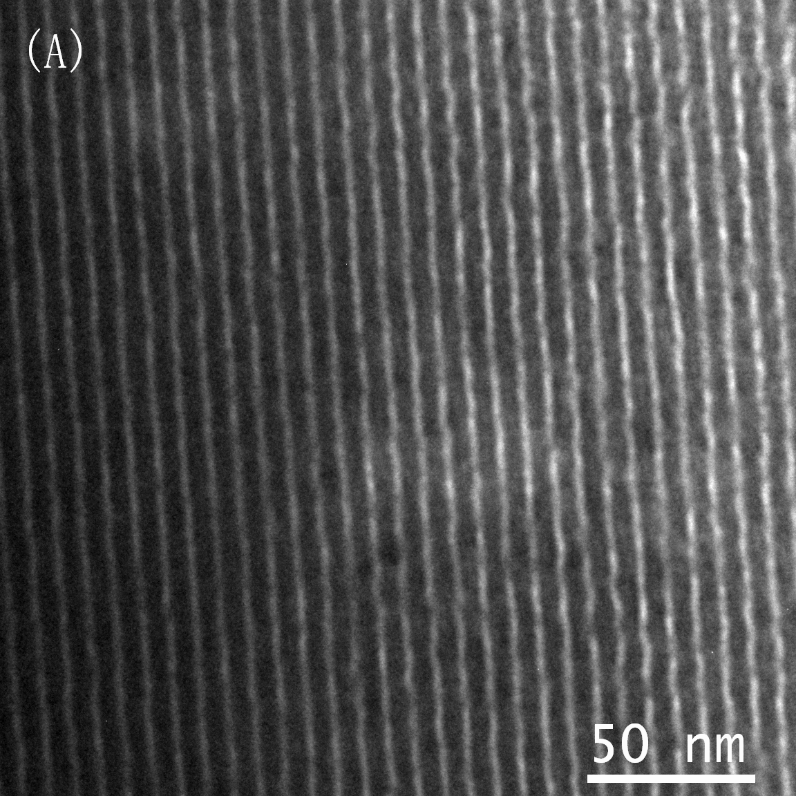 | 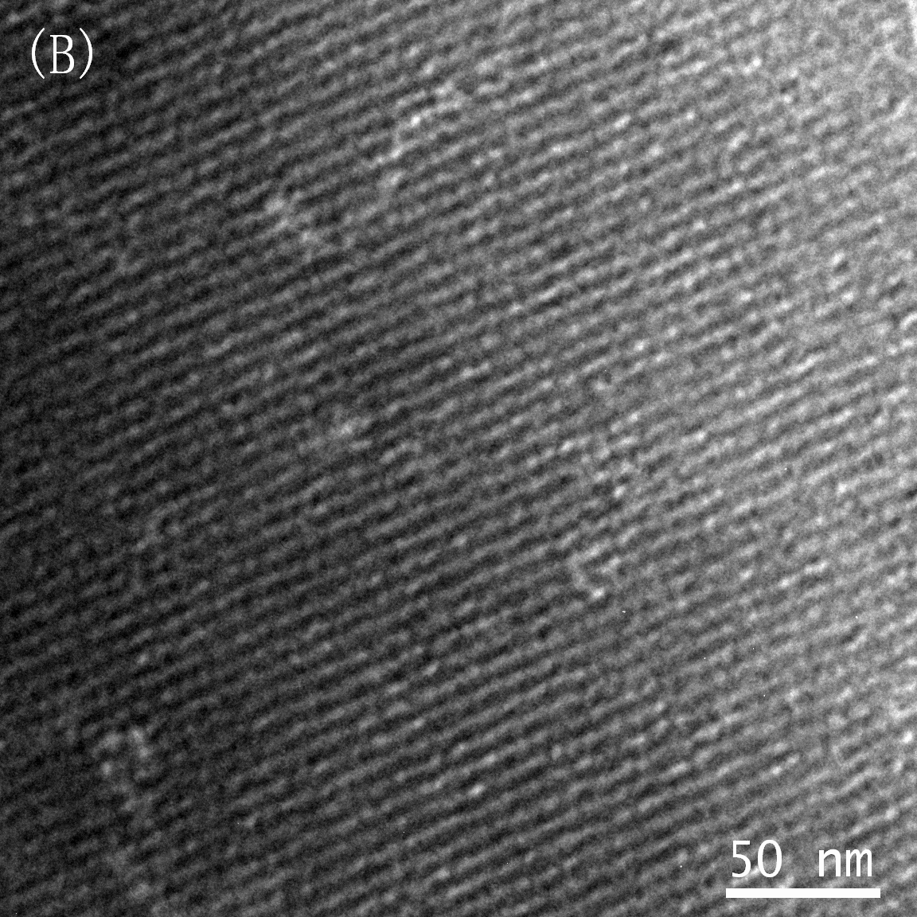
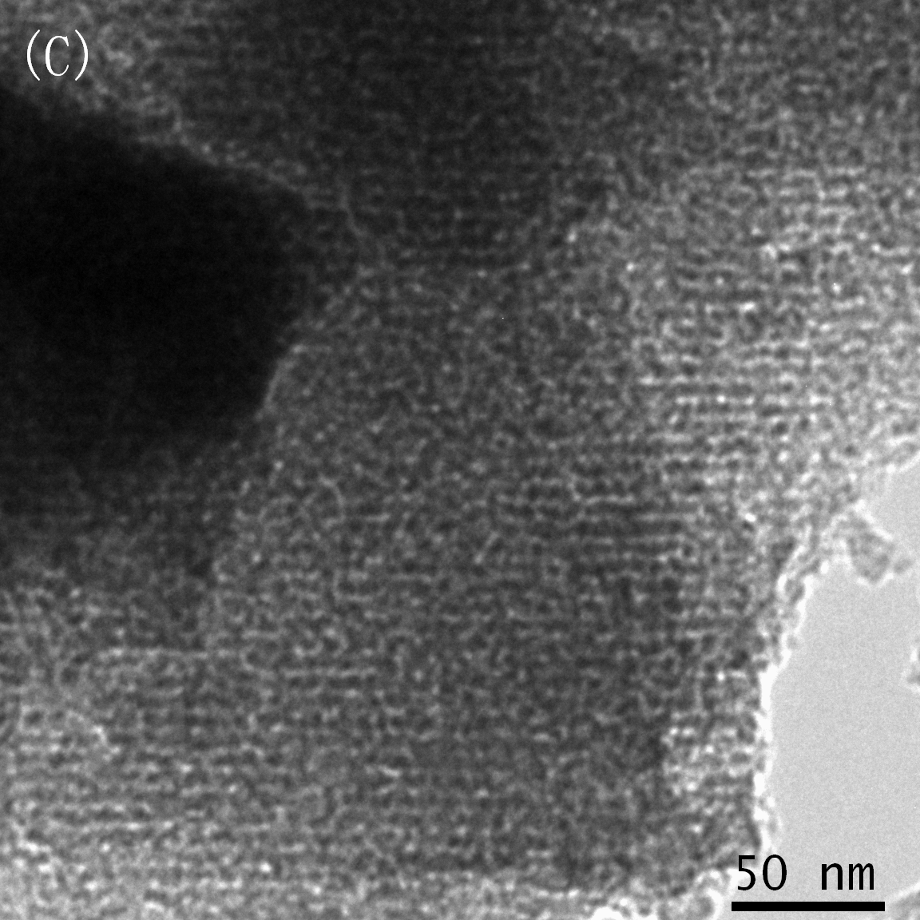 | 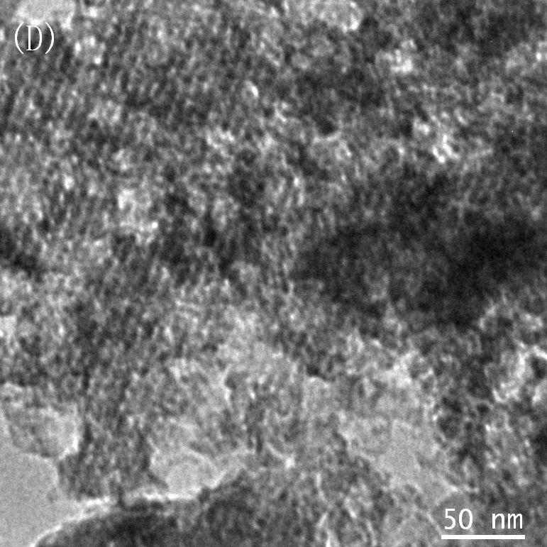
Figure 2. TEM images of the typical unactivated and activated samples: (A) C-FDU-15; (B) AOMC-CS31; (C) AOMC-CS65 and (D) AOMC-CS73

Figure 3. N₂ adsorption-desorption isotherms of C-FDU-15 and related activated samples

Table 1. Pore structure parameters of the precursor C-FDU-15 and related activated ordered mesoporous carbons with channel structure with various burn-offs
Sample | Burn-off  (wt%) | S_{BET}  (m²/g) | S_{mic}  (m²/g) | V_{t}  (cm³/g) | V_{mic}  (cm³/g)
C-FDU-15 | 0* | 612 | 362 | 0.34 | 0.17
AOMC-CS31 | 30.8 | 1222 | 797 | 0.67 | 0.37
AOMC-CS65 | 64.7 | 2004 | 1096 | 1.10 | 0.50
AOMC-CS73 | 72.8 | 1696 | 838 | 1.22 | 0.38
*: 0wt% of burn-off represents no activation treatment imposed on the precursor C-FDU-15.

Figure 3 shows the N₂ adsorption-desorption isotherms of the precursor C-FDU-15 and related AOMCs-CS with various burn-offs. Within burn-off range of 0~65 wt%, the larger the burn-off, the greater is the adsorption amount. Especially, the uptake at relative low pressure sharply increases with increasing the burn-off. This suggests that in such a burn-off range, the larger the burn-off, the greater is the micropore amount. Indeed, it can be clearly seen from Table 1 that when increasing the burn-off from 0 wt% for C-FDU-15 to 31 wt% for AOMC-CS31, and to 65 wt% for AOMC-CS65, the corresponding volume and surface area of micropores clearly increase from 0.17 cm³/g and 362 m²/g to 0.37 cm³/g and 797 m²/g, and to 0.50 cm³/g and 1096 m²/g. From the Figure 3, it can be found that the precursor C-FDU-15 and related AOMC-CS with burn-offs below 65 wt% exhibits similar type-IV isotherms with distinct hystersis loops, implying that the channel mesopores of the precursor are preserved during the activation treatment, which is in good agreement with the results from the XRD patterns and TEM images.
Figure 4. DFT pore size distributions of FDU-15 and related activated samples

It can be vividly shown that the N₂ adsorption-desorption isotherm of AOMC-CS73 with 73 wt% is obviously different from those of the precursor and other activated samples with lower burn-offs. A great increase of adsorption amount at relative pressures above 0.9 in the isotherm of the AOMC-CS73 occurs, implying that larger mesopore and/or macropore systems are generated in the continuous carbon skeletal wall in the case of such a high burn-off of 73 wt%. Figure 4 shows that these generated larger pores mainly distribute in the range of 10~100 nm and have a maximum at ca. 37 nm. Correspondingly, the average mesopore diameter of the AOMC-CS73 is 6.5 nm, larger than that of C-FDU-15 and related activated samples with lower burn-offs. And most importantly, a distinct hystersis loop in the medium range of relative pressure is still found in the isotherm of the AOMC-CS73 and its shape is very like those of others, implying that even with such a high burn-off, e.g. 73 wt%, the basic ordered structure can still exist in the as-prepared AOMCs-CS. This is consistent with the results of the results from the XRD patterns and TEM images. Kaneko and co-workers have also reported that an intense activation treatment with 72 wt% of burn-off does not change the basic network structure of carbon aerogels composed of continuous carbon nano-framework, although a partial opening of the network structure occurs14. In contrast, Gao and co-workers have found that upon intense activation, the basic ordered mesostructure of ordered mesoporous carbon CMK-3 will be thoroughly destroyed.¹⁰ Therefore, we suppose that the continuous carbon skeletal structure in the precursor C-FDU-15 plays a very important role in preserving the basic ordered mesostructure of related activated samples with high burn-offs, e.g. 73 wt%.

3.2 Electrochemical characterization. Table 2 shows the mass specific capacitance (C_{m}) and equivalent series resistance (ESR) of AOMCs-CS. It can be seen that CO₂ activation obviously increases the C_{m} of the AOMCs-CS in varying degrees. The highest C_{m} reached 191 F/g at 10 mV/s, which is much higher than that of non-activated sample. It illuminates that activation increase the BET area, resulting in an increase in the C_{m}, and high surface area is profitable for the electrochemical performance. However, it was found that the specific double layer capacitance of samples is not proportional to total surface area. For example, although the surface area of AOMC-CS65 is higher than that of AOMC-CS73, the latter sample exhibits a higher mass specific capacitance values. It implies not all the BET surface area is electrochemically accessible, and apart from surface area other factors also contribute to the capacitance of these carbons to a considerable extent, e.g. pore size distribution.15 Generally, the easier the accessibility of the ions to the electrochemically active surface is, the higher the capacitance values are. ⁸ Therefore, taking into account the fact that there are some larger mesopores and macropores in the samples of AOMC-CS73, which are generated from the punching action during the intense activation, these large pores distributing among the mesotunnels are key to a rapid mass transport and a better accessibility of ions to the electrochemically active surface.

Table 2. Effect of sweep rate on the mass specific capacitance (C_{m}) and the EDL specific capacitance (C_{edl}) and equivalent series resistance (ESR) of the precursor C-FDU-15 and related activated carbons electrodes

Sample name | 10 mV/s |  |  | 50 mV/s |  |  | 100 mV/s |  |  | ESR (Ohm)
Sample name | C_{m}  (F/g) | C_{edl}  (μF/cm²) |  | C_{m}  (F/g) | C_{edl}  (μF/cm²) |  | C_{m}  (F/g) | C_{edl}  (μF/cm²) |  | at10mHz
C-FDU-15 | 141 | 23.0 |  | 128 | 20.9 |  | 114 | 18.6 |  | 7.40
AOMC-CS31 | 154 | 12.6 |  | 133 | 10.9 |  | 107 | 8.8 |  | 9.11
AOMC-CS65 | 173 | 8.6 |  | 151 | 7.5 |  | 130 | 6.5 |  | 12.98
AOMC-CS73 | 191 | 11.3 |  | 155 | 9.1 |  | 132 | 7.8 |  | 29.50

Figure 5. Complex plane plots (Nyquist plots) of the precursor C-FDU-15 and related activated carbons electrodes.
Figure 6. Resistance (Z') vs. frequency for the precursor C-FDU-15 and related activated carbons electrodes.

As a rule, a higher charging resistance appears compared to the non-activated carbon electrode. Moreover, the resistance increases with the increasing burn-off, reducing pore accessibility as well as resulting in a decreasing electric double layer (EDL) specific capacitance (C_{edl})16-18. For quantificationally reflecting the influence of activation on the equivalent series resistance (ESR), we used electrochemical impedance spectroscopy (EIS) as a technique for the investigation of the capacitive behavior of the frequency dependence. Impedance spectra for the electrodes are presented in Figure 5. The plots exhibit distinct semicircle in the high frequency range for the activated samples (e.g. AMOS-CS73) and the larger the burn-off is, the bigger the semicircle is. It indicates the ESR continuously rise along with the increasing burn-off as expected. In the Figure 6, the same tendency occurs and a highest ESR of AMOS-CS73 can be visibly observed. Meanwhile, we note that C_{edl} also decline within burn-off range of 0~65 wt% from Figure 7. It is interesting to note that C_{edl} abnormally increase when the burn-off is up to 73%, suggesting that the existence of large mesopore and macropore of AMOS-CS73 would benefit to quick mass transportation of electrolyte ions to the bulk of the material when it was used as electrode material in supercapacitors. In addition, in spite of possessing a higher ESR, AMOS-CS73 display the better C_{edl}, proving effectively that the additional large pores and the formation of those interconnected channels during the intense activation is profitable for the performance of mass transport. As a result, it can help for accessibility of the ions to energy storage surface and enhancement of pore utilization rate.
Figure 7. Effect of burn-off on the C_{edl} with various sweep rates.

4. Conclusions

AOMCs-CS have been successfully prepared. The order degree of AOMCs-CS is basically unvaried in burn-off range below 31 wt% and subsequently gradually becomes lower with further increasing the burn-off to 73 wt%. As highlighted here, due to the existence of continuous carbon skeletal wall, even such an intense activation with 73wt% of burn-off does not thoroughly destroy the ordered mesostructure. With increasing the burn-off, the amount of micropores first increases and then decreases, and the amount of mesopores continuously increases. When the burn-off reaches 73 wt%, a few of larger pores with a pore size distribution centered at ca.37 nm are generated among the neighboring channels. The investigation on the electrochemical performances shows the formation of these interconnected channels and large pores is profitable for the performance of mass transport. Hence, it can help for accessibility of the ions to the electrochemically active surface and enhancement of pore utilization rate.

具有高传质性能的有序中孔炭材料的纳米结构设计、制备及其在超级电容器中的应用

梁业如 吴丁财 符若文

中山大学材料科学研究所，广州，510275
教育部聚合物复合材料及功能材料重点实验室

摘要：利用CO₂活化法对二维六方有序中孔炭材料C-FDU-15进行刻蚀改性，成功得到含有隧道状孔道的有序中孔活性炭材料（AOMCs-CS），由于炭墙的三维连续性，即使在高的烧失率（如73％）下，基本的有序中孔结构仍能得到保持，且部分炭墙被钻穿，引入了大尺度中孔结构。电化学测试结果表明，随着烧失率的增大，材料电极的质量比电容与电阻持续增大，烧失率为73％时的AOMCs-CS尽管经过严重的刻蚀后具有较大电阻，但由于引入了大尺度中孔，改善了孔道间相互贯穿性，电解液能够容易地进入的孔道使得孔隙利用率高，电双层比电容量不降反而提高，充分体现了其纳米结构传质性能的优越性。

关键词：有序中孔炭；活化；高传质；超级电容器。

1 * Corresponding author Tel: +86-020-84114527, Fax: +86-020-84115112, E-mail: cesfrw@mail.sysu.edu.cn (1) Azais, P.; Duclaux, L.; Florian, P.; et al. J. Power. Sources 2007, 171, 1046. (2) Fang, B. Z.; Binder, L. Electrochimica Acta. 2007, 52, 6916. (3) Centeno, T. A.; Hahn, M.; Fernández, J. A.; et al. Electrochemistry Communications 2007, 9, 1242. (4) Lee, J. W.; Yoon, S. H.; Hyeon, T.; et al. Chem.Commun. 1999, 2177. (5) Jurewicz, K.; Vix-Guterl, C.; Frackowiak, E.; et al. J. Phys. Chem. Solids 2004,65, 287-293. (6) Conway, B. E. Electrochemical Supercapacitors; Kluwer Academic: New York, 1999. (7) Frackowiak, E. Phys.Chem.Chem.Phys. 2007, 9, 1774.
1 (8) Li, L. X.; Song, H. H. Chen, X. H. Electrochimica Acta. 2006, 51, 5715. (9) Vix-Guterl, C.; Frackowiak, E.; Parmentier, J.; et al. Carbon 2005, 43, 1293. (10) Xia, K. S.; Gao, Q. M.; Wu, C. D.; et al. Carbon 2007, 45,1989.
1(11) Zhao, D. Y.; Feng; J. L.; Huo, Q. S.; et al. Science 1998, 279, 548. (12) Meng, Y.; Gu, D.; Zhang, F. Q.; et al. Chem. Mater. 2006, 18, 4447. (13) Kruk, M.; Jaroniec, M.; Sayari, A. Langmuir 1997, 13, 6267.
1 (14) Hanzawa, Y.; Pekala, R. W.; Dresselhaus, M. S.; et al. Langmuir 1996, 12, 6167.
1 (15) Gryglewicz, G.; J. Machnikowski, J.; Frackowiak, E.; et al. Electrochimica. Acta. 2005, 50, 1197.
1 (16) Pröbstle, H.; Schmitt, C.; Fricke, J. J. Power Sources 2002, 105, 189. (17) Wang, Y. S.; Wang, C.Y.; Guo, C. Y.; et al. Journal of Physics and Chemistry of Solids 2008, 69, 16. (18) Shi, H. Electrochimica Acta. 1996, 41, 1639.

