Template-free electrosynthesis of CeO₂ order nanowire arrays and its application for direct methanol fuel cell
Xi-Hong Lu, Gao-Ren Li, Jian-Qing Ye, Ye-Xiang Tong*
MOE of Key Laboratory of Bioinorganic and Synthetic Chemistry/School of Chemistry and Chemical Engineering,Sun Yat-Sen University, Guangzhou 510275, China

Abstract A simple and economical route based on template-free electrochemical deposition was developed to synthesize the large scale uniform polycrystalline CeO₂ nanowire arrays (NWA) from aqueous solution. SEM, EDS, XPS, XRD, TEM, HRTEM, and SAED were used to characterize the morphology, composition, phase, and structure of the prepared CeO₂ NWA. The electrochemical activity and stability of Pt catalyst supported on commercial CeO₂ powder and these prepared CeO₂ NWA for methanol oxidation were investigated in 1.0 mol·L⁻¹ KOH + 1.0 mol·L⁻¹ CH₃OH solution by cyclic voltammetry and chronoamperometry, respectively. The results indicate that the composite of Pt/CeO₂ NWA gave the better performance than pure Pt and Pt/CeO₂ (commercial powder).

- Introduction

Direct methanol fuel cell (DMFC) is considered to be one of the most promising power sources due to its higher energy density than gaseous fuels and its application for portable electronic devices.^{[1-2]} DMFC generates electric power by feeding a methanol fuel directly to an anode. However, some obstacles such as the low methanol electrooxidation kinetics and high methanol crossover through the membrane are found for the applications of DMFC. The CO species produced during the process of methanol electrooxidation is the primary reason for the kinetic impediment of methanol electrooxidation. Thus, more and more work has been focused on reducing or removing the CO species, and significant progress has been acquired. Oxide modified Pt electrocatalysts is widely accepted as one of effective approach to solve this problem.^{[3-6]}
As one of the most reactive rare earth oxides, ceria has attracted a great deal of interest due to its high mechanical strength, oxygen ion conductivity, optical property, thermal stability, and oxygen storage capacity. It has been widely applied in the field of catalysts, fuel cells, UV blockers, ceramics, oxygen storage capacitors, and humidity sensors.^{[7-12]} In the past few years, much attention has been focused on controlled synthesis of CeO₂ one-dimemsional (1D) nanostructured due to Stimulated by the unique properties and potential applications. Recently, the CeO₂ nanorods,^{[13-14]} nanowires,^{[15-16]} nanotubes,^{[17-18]} and nanobelts^{[19]} have been reported. The previously reported CeO₂ nanorods/nanowires were generally prepared by the template-assisted or the surfactant-assisted methods, which means relatively complicated, high cost, and always need high-temperature, high-pressure, or long-time treatments.^{[20-22]} Therefore, it is still a challenge to develop a one-step synthesis method to prepare the CeO₂ NWA. Moreover, CeO₂ has been demonstrated as a good support for Pt catalyst to promote the catalytic activity and stability for the methanol electrooxidation reaction in alkaline media.^{[23-26]}
Herein, we first demonstrate a simple, rapid, economical, and one-step technique to synthesize the large scale uniform polycrystalline CeO₂ NWA from aqueous solution via template-free electrochemical deposition. We further prepared Pt catalyst supported on CeO₂ NWA composite and investigated its application for the direct oxidation of methanol in alkaline media.

2. Experiment Section
2.1 Preparation of the CeO₂ NWA
Electrodeposition of the CeO₂ NWA was performed in solution of Ce(NO₃)₃, CH₃COONH₄, and KCl via galvanostatic electrolysis with the current densities of 2.0 - 4.0 mA·cm⁻². A simple three-electrode glass cell was used in our experiment, which was immersed in an oil bath set at 70 °C. The working electrode was a titanium substrate with a geometric surface area of ca. 3.0 cm², and the titanium foil was cleaned ultrasonically in 0.1 mol·L⁻¹ HCl, distilled water, and acetone and then rinsed in distilled water again before electrodeposition. A graphite rod of about 4.0 cm² was used as the auxiliary electrode and a saturated calomel electrode (SCE) as the reference electrode that connect to the cell with a double salt bridge. All potential values determined in this experiment were the values versus SCE.

2.2 Preparation of Pt, Pt/CeO₂, and Pt/CeO₂ NWA electrodes.
The Pt/CeO₂ and Pt/CeO₂ NWA electrodes were prepared by the homologous
method reported by Xu et al.^{[27-28]} The Pt/CeO₂ catalysts were synthesized through the reduction of H₂PtCl₆ solution on CeO₂ nanowire powders and commercial CeO₂ powders (99.95%, purchase form Sinopharm Chemical Reagent Co. ) by using 0.01 mol·L⁻¹ NaBH₄ solution. Typically, the CeO₂ nanowire powders were dispersed in 0.01 mol·L⁻¹ H₂PtCl₆ solution under ultrasonic stirring for ten minutes, and superfluous 0.01 mol·L⁻¹ NaBH₄ was added into the mixture solution to reduce Pt ions. Then, the obtained catalysts were cleaned in distilled water repetitious until the value of PH of the filter liquor reached to 7.0, and dried at 80 °C for 24 hours. Finally, the catalysts powders were dispersed in 2-propanol with 5w% Nafion solution under ultrasonic stirring, and the mixture solution was deposited on the surface of a graphite rod with the geometric area of 0.50 cm² and dried at 80 °C for 30 min. The Pt loadings on the Pt, Pt/CeO₂, and Pt/CeO₂ NWA electrodes were controlled at 0.42 mg·cm⁻¹.

2.3 Characterization and Electrochemical Measurements
The surface morphology of the CeO₂ NWA was observed by field emission scanning electron microscope (FE-SEM, JSM-6330F). The obtained deposits were also characterized by using energy-dispersive spectroscopy (EDS, FEI/Quanta 400), X-ray diffractometry (D/MAX 2200 VPC with Cu Ka radiation), and X-ray photoelectron spectroscopy (XPS, ESCALAB 250). Transmission electron microscopy (TEM, JEM-2010HR) was also used to characterize the structure of the CeO₂ NWA.
The electrochemical measurements were carried out in a three-electrode glass cell using CHI 750a electrochemical workstation (Chenhua, Shanghai). The Pt, Pt/CeO₂, and Pt/CeO₂ NWA electrodes were used as the working electrode. A platinum foil (3.0 cm²) and a saturated calomel electrode were used as counter and reference electrodes, respectively. All the solutions were freshly prepared.

- Results and Discussion

The electrodeposition was carried out in solution of 0.01 mol·L⁻¹ Ce(NO₃)₃ + 0.02 mol·L⁻¹ CH₃COONH₄ + 0.05 mol·L⁻¹ KCl with a current density of 2.0 mA·cm⁻² for 120 min at 70 ℃. The CeO₂ order NWA were successfully synthesized on the Cu substrate, and the typical SEM images are shown in Figure 1. As shown as Figure 1(a), it can be clearly seen that the deposit are CeO₂ NWA, which grew vertically aligned with the substrate. The typical lengths of CeO₂ nanowires are about 11 μm. The high-magnification SEM image of CeO₂ deposits is shown in Figure 1(b), and it reveal that the diameters of these nanowires are about 50 nm.
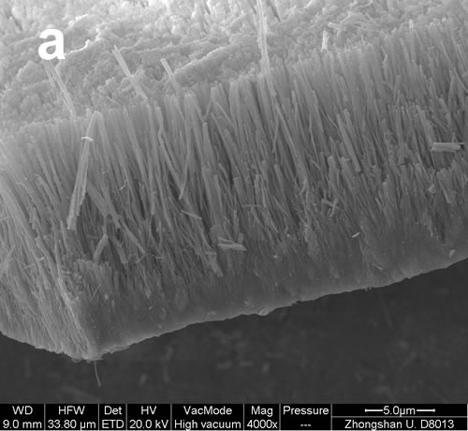 | 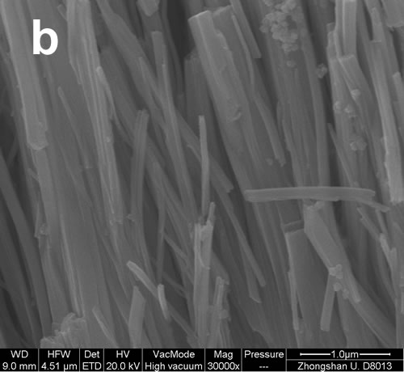
Figure 1. SEM images of the prepared CeO₂ in solution of 0.01 mol·L⁻¹ Ce(NO₃)₃ + 0.02 mol·L⁻¹ CH₃COONH₄ + 0.05 mol·L⁻¹ KCl with a current density of 2.0 mA·cm⁻² for 120 min at 70 ℃. (a) 4,000; (b) 30,000
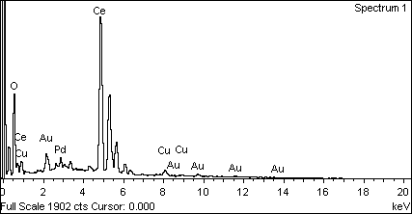
Figure 2. EDS spectrum of the prepared CeO₂ in solution of 0.01mol·L⁻¹ Ce(NO₃)₃ + 0.02 mol·L⁻¹ CH₃COONH₄ + 0.05 mol·L⁻¹ KCl with a current density of 2.0 mA·cm⁻² for 120 min at 70 ℃

To confirm the compositions of deposits, EDS measurement was carried out at a large of locations throughout the deposits. The representative EDS pattern was shown in Figure 2. The peaks of element Ce, O, Cu, Au, and Pd were detected in the EDS pattern. The Cu peak corresponds to the Cu substrate, and the Pd, Au peaks are according to Pd, Au sprayed on substrate. Therefore the EDS result demonstrates the elements of Ce, and O existed in the obtained nanowires. In order to verify the valence conditions of Ce in the obtained deposits, surface analysis of the CeO₂ NWA was carried out by X-ray photoelectron spectroscopy (XPS, ESCALAB 250). The XPS spectrum of deposits is presented in Figure 3. The Ce 3d_{3/2} peak at about 915.7 eV and 899.7 eV, which revealed Ce exists as the Ce(IV) oxidation state in the deposits. But the Ce 3d_{5/2} peak at about 881.7 eV, indicating a small quantity of impurity of the Ce(III) oxidation state existed in the deposits.^{[29-30]} In addition, the O1s peak at ca. 531.6 eV in Figure 3b can be attributed to O²⁻. Thus the XPS results suggest the obtained deposits are CeO₂, which is consistent with the EDS result.
Figure 3. XPS spectra of the prepared CeO₂ in solution of 0.01 mol·L⁻¹ Ce(NO₃)₃ + 0.02 mol·L⁻¹ CH₃COONH₄ + 0.05 mol·L⁻¹ KCl with a current density of 2.0 mA·cm⁻² for 120 min at 70 ℃
Figure 4. XRD pattern of the prepared CeO₂ in solution of 0.01 mol·L⁻¹ Ce(NO₃)₃ + 0.02 mol·L⁻¹ CH₃COONH₄ + 0.05 mol·L⁻¹ KCl with a current density of 2.0 mA·cm⁻² for 120 min at 70 ℃

The crystal structure of the prepared CeO₂ NWA was also analyzed by power X-ray diffraction (XRD). Figure 4 shows a representative XRD pattern. Four peaks at about 28.54, 33.13, 47.49, and 56.37 degrees can be indexed to (111), (200), (220), and (311) of face-centered cubic-phase CeO₂ with lattice constants a = 5.411 Å. (JCPDS card 65-2975). No any other peaks are detected besides Cu peaks that come from the substrate. The XRD result further indicates that the deposits are CeO_{2.}
The microstructural details of CeO₂ NWA were further investigated by TEM. Figure 5a shows a low-magnification TEM image of single CeO₂ nanowire. The diameter of this nanowire is about 50 nm, which is in agreement with the SEM. Figure 3b shows a high-resolution TEM (HRTEM) image of the circled area in Figure 5a. It can be clearly seen that it is consisted of many tiny grains of different orientations. The selected-area electron diffraction pattern (SAED, inset in Figure 5b) further indicates that the structure of the nanowire is a polycrystalline structure and is face-centered cubic CeO₂. The result is identical with that of XRD.

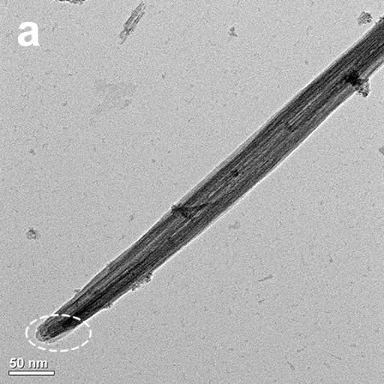 | 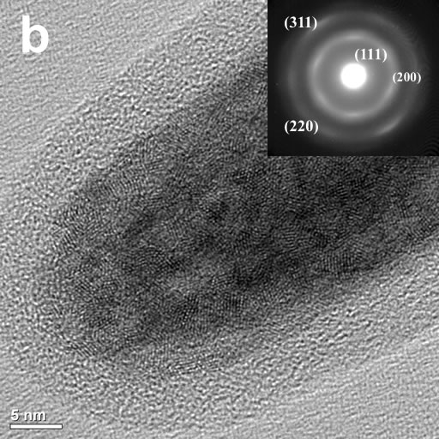
Figure 5. TEM image (a), HRTEM image (b), and SAED pattern (inset) of the prepared CeO₂ in solution of 0.01 mol·L⁻¹ Ce(NO₃)₃ + 0.02 mol·L⁻¹ CH₃COONH₄ + 0.05 mol·L⁻¹ KCl with a current density of 2.0 mA·cm⁻² for 120 min at 70 ℃

Figure 6 shows the cyclic voltammograms of methanol oxidization on Pt, Pt/CeO₂, and Pt/CeO₂ NWA electrodes with a platinum loading of 0.42 mg·cm⁻² at 25 ℃ in 1.0 mol·L⁻¹ KOH + 1.0 mol·L⁻¹ CH₃OH solution, respectively. The sweep rate is 5 mV· s⁻¹ in the potential range from - 0.9 to 0.3 V. It is clearly observed two current peaks occurred on all electrodes. The forward scan peak is corresponding to the oxidation freshly chemisorbed species originating from methanol adsorption. And the reverse scan peak is attributed to removal of carbonaceous species not completely oxidized in the forward scan.^{[31-33]} The electrochemical performances for the methanol oxidation reaction including the onset potential (E_{s}), the forward anodic peak potential (E_{p}), the current densities (j_{p}) at E_{p} and at a potential of −0.3V (vs. Hg/HgO) are shown in Table 1. The peak current density (j_{p}) and the current density at −0.3V for methanol oxidation on Pt/CeO₂ NMA electrode are about 4 times and 2 times than that on Pt electrode, respectively. The onset potential (Es) for methanol oxidation on Pt/CeO₂ NMA electrode is the same as that on Pt electrode at the uniform condition. The peak current density of methanol oxidation on Pt/CeO₂ electrode is 2 times than that on Pt electrode. However, the current density at −0.3 V for methanol oxidation is smaller than that on Pt electrode, and the onset potential (Es) for methanol oxidation on Pt/CeO₂ electrode is more positive about 50 mV compared with those on Pt electrode and Pt/CeO₂ NMA electrode. The result shows that Pt/CeO₂ NMA has much higher catalytic activity for methanol electrooxidation than Pt and Pt/CeO₂ in alkaline medium.
Figure 6. Cyclic voltammograms of methanol oxidation on Pt, Pt/CeO₂, and Pt/CeO₂ NWA electrodes with a platinum loading of 0.42 mg·cm⁻² in 1.0 mol·L⁻¹ KOH + 1.0 mol·L⁻¹ CH₃OH solution with a sweep rate of 5 mV· s⁻¹, 25 ℃

Table 1 Performance of three electrodes in alkalin methanol solution, 25 ℃
Electrocatalyst | E_{s} (V) | E_{p} (V) | j_{p} (mA·cm⁻²) | j at -0.30 V (mA·cm⁻²)
Pt | -0.60 | -0.22 | 5.5 | 4.0
Pt/CeO₂ | -0.55 | -0.17 | 11.1 | 3.7
Pt/CeO₂ NWA | -0.60 | -0.12 | 20.2 | 9.8

The mechanism of methanol electrooxidation on Pt/CeO₂ catalysts was studied here. The methanol oxidation to CO₂ occurs at the anode and the reduction of oxygen to water occurs at the cathode in alkaline medium. These reactions can be described as follow:^{[34]}
Anode: CH₃OH + 6OH⁻ CO₂ + 5H₂O + 6e⁻ (1)
Cathode: 3/2O₂ + 3H₂O + 6e⁻ 6OH⁻ (2)
The overall oxidation of methanol is
CH₃OH + 3/2O₂ CO₂ + 2H₂O (3)
However, it is known that CO species will be formed during reaction process which results in poisoning for the electrocatalysts. It is the main reason for the kinetic impediment of methanol electrooxidation.^{[35]} As one of the most excellent incorporation of oxygen, CeO₂ can lead to increase the local oxygen concentration in the catalyst. Sequentially, it can promote CO electrooxidation easier, which may be one reason for increased methanol electro-oxidizing current in Figure 6.^{[36]} The mechanism of CO electrooxidation can be suggested as follows:
Pt + CH₃OH + 4OH⁻ Pt-CO_{ads} + 4H₂O + 4e⁻ (4)
CeO₂ + OH⁻ CeO₂-OH_{ads} + e⁻ (5)
Pt-CO_{ads} +CeO₂-OH_{ads} + OH⁻ Pt-CeO₂ + CO₂ + H₂O (6)
In the alkaline media, Pt-CO_{ads} is fromed by the methanol dehydrogenation as describe as Eq. (4), and the CeO₂-OH_{ads} is formed by the OH⁻ anion adsorption on CeO₂ surface (Eq. (5)). Then CO-like poisoning species (CO_{ads}) on Pt were transformed to CO₂ by reacting with the produced CeO₂-OH_{ads} as Eq. 6. And it releases the active sites on Pt for further reaction.^{[37-39]} Thus, CeO₂ can promote the activity and stability of Pt electrocatalysts for the methanol electrooxidation reaction in alkaline media.
Figure 7. Current–time curves for methanol oxidation at -0.30 V on Pt, Pt/CeO₂, and Pt/CeO₂ NWA electrodes with a platinum loading of 0.42 mg·cm⁻² in 1.0 mol·L⁻¹ KOH + 1.0 mol·L⁻¹ CH₃OH solution, 25 ℃

The electrochemical stability of Pt, Pt/CeO₂, and Pt/CeO₂ NMA electrodes for methanol electrooxidation was also investigated by chronoamperometric experiment at a potential of -0.30 V in 1.0 mol·L⁻¹ KOH + 1.0 mol·L⁻¹ CH₃OH solution at 25 ℃. The results are shown in Figure 7. It can be seen that the current for methanol electrooxidation reaction shows a rapid decay, indicating the poisoning for the electrocatalysts.^{[31]} Nevertheless, the oxidation current on Pt/CeO₂ NMA electrode keeps higher than that on Pt electrode and Pt/CeO₂ electrode during the whole test range. In the same time, the oxidation current is larger on Pt/CeO₂ electrode than that on Pt electrode. It indicates that CeO₂ can promote the electrochemical stability of Pt electrocatalysts for the methanol electrooxidation reaction in alkaline media, and the nanowire structure has a better performance than the particle in the promotion of activity and stability of Pt electrocatalysts. The conclusion is consistent with the CV results.

- Conclusion
In summary, the CeO₂ NWA were successfully synthesized via a template-free electrochemical deposition from aqueous solution. The results of SEM, EDS, XPS, XRD, TEM, HRTEM, and SAED reveal that the prepared deposits are polycrystalline CeO₂ NWA with a diameter of 50 nm and a length of 11 μm. Furthermore, the results of CV and chronoamperometry in the present study show that CeO₂ NWA are a good support for Pt catalyst. The Pt/CeO₂ NWA electrode has a higher catalytic activity and more stable performances for the methanol electrooxidation reaction in alkaline media than that on Pt electrode and Pt/CeO₂ electrode.

Acknowledgment.
This work was supported by the Natural Science Foundations of China (Grant Nos. 20603048 and 20573136) and Open Fund of Laboratory of Sun Yat-Sen University (KF200702).

References
- Barragάn, V. M.; Heinzel, A. J. Power Sources 2002, 104, 66.
- Tang, H. L.; Wang, S. L.; Pan, M.; Jiang, S. P.; Ruan, Y. Z. Electrochim. Acta 2007, 52, 3714.
- Park, K. W.; Ahn, K. S.; Nah, Y.C.; Choi, J. H.; Sung, Y.E. J. Phys. Chem. B. 2003, 107, 4352.
- Xu, C. W.; Tian, P. K.; Shen, P. K.; Jiang, S. P. Electrochim Acta 2008, 53, 2610.
- Hang, X.; He, D. H.; Zhang, Q. J.; Xu, B. Q.; Zhu, Q. M. Stud. Surf. Sci. Catal. 2004, 147, 541.
- Wang, Y.; Fachini, E. R.; Cruz, G.; Zhu, Y. M.; Ishikawa, Y.; Carlos, R. J. Electrochem. Soc. 2001, 148, C222.
- Masui, T.; Fujiwara, K.; Machida, K. I.; Adachi, G. Y. Chem. Mater. 1997, 9, 2197.
- Shao, Z. P.; Haile, S. M.; Ahn, J. M.; Ronney, P. D.; Zhan, Z. L.; Barnett, S. A. Nature. 2005, 435, 795.
- Jasinski, P.; Suzuki, T.; Anderson, H. U. Sen. Actuators, J. Electrochem. Soc. 2004, 151, A1678.
- Yamashita, M.; Yabe, K. S.; Yoshida, S.; Fujisiro, Y.; Kawai, T.; Sato, T. J. Mater. Sci. 2002, 37, 683.
- Park, S. D.; Vohs, J. M.; Gorte, R. J. Nature. 2000, 404, 265.
- Fu, X. Q.; Wang, C.; Yu, Y. G.; Wang, T. H. Nanotechnology 2007, 18, 145503.
- Sayle, D. C.; Feng, X.; Ding, Y.; Wang, Z. L.; Sayle, T. J. Am. Chem. Soc. 2007, 129, 7924.
- Du, N.; Zhong, H.; Chen, B. D.; Ma, X. Y.; Yang, D. R. J. Phys. Chem. C, 2007, 111, 12677.
- Tang, B.; Zhuo, L. H.; Ge, J. C.; Wang, G. L.; Shi, Z. Q. Niu, J. Y. Chem. Commun. 2005, 28, 3565.
- Yang, R.; Guo, L. J. Mater. Sci. 2005, 40, 1305.
- Chen, G. Z.; Xu, C. X.; Song, X. Y.; Zhao, W.; Ding, Y.; Sun, S. X. Inorg. Chem. 2008, 47, 723.
- Inguanta, R.; Piazza, S.; Sunseri, C. Nanotechnology 2007, 18, 485605.
- Li,G. R.; Qu, D. L.; Tong, Y.X. Electrochem. Commun. 2008, 10, 80.
- La, R. J.; Hu, Z. A.; Li, H. L.; Shang, X. L.; Yang, Y. Y. Mater. Sci. Eng. 2004, 368, 145.
- Vantomme, A.; Yuan, Z. Y.; Du, G.; Su, B. L. Langmuir. 2005, 21, 1132.
- Yada, M.; Sakai, S.; Torikai, T.; Watari, T.; Furuta, S.; Katsuki, H. Adv. Mater. 2004, 16, 1222.
- Wang, J. S.; Xi, J. Y.; Bai, Y. X.; Shen, Y.; Sun, J.; Chen, L. Q.; Zhu, W. T.; Qiu, X. P. J. Power Sources 2007, 164, 555.
- Takahashi, M.; Mori, T.; Vinu, A.; Oa, D. R.; Kobayashi, H.; Drennan, J. Adv. Appl. Ceramics. 2008, 107, 57.
- Wang, J. S.; Deng, X. Z.; Xi, J. Y.; Chen, L. Q.; Zhu, W. T.; Qiu, X. P. J. Power Sources 2007, 170, 297.
- Huang, S.Y.; Chang, C. M.; Yeh, C. T. J. Catal. 2006, 241, 400.
- Xu, C. W.; Shen, P. K. J. Power Sources 2005, 142, 27.
- Shen, P. K.; Xu, C. W. Electrochem. Commun. 2006, 8, 184.
- Dauscher, A.; Hilaire, L.; LeNormand, F.; Muller, W.; Maire, G.; Vasquez, A. Surf. Interface Anal. 1990, 16, 341.
- Huang, P. X.; Wu, F.; Zhu, B. L.; Gao, X. P.; Zhu, H.Y.; Yan, T. Y.; Huang, W. P.; Song, D. Y. J. Phys. Chem. B. 2005, 109, 1916.
- Ye, J. Q.; Liu, J. P.; Xu, C. W.; Jiang, S. P.; Tong, Y. X. Electrochem. Commun. 2007, 9, 2760.
- Morin, M.C.; Lamy, C.; Le´ger, J.M. J. Electroanal. Chem. 1990, 283, 287.
- Huang, J. C.; Liu, Z. L.; He, C. B.; Gan, L. M. J. Phys. Chem. B. 2005, 109, 16644.
- Christensen, P.A.; Hamnett, A.; Troughton, G. L. J. Electroanal. Chem. 1993, 362, 20.
- Yajima, T.; Uchida, H.; Watanabe, M. J. Phys. Chem. B. 2004, 108, 2654.
- Carrettin, S.; Concepcion, P.; Corma, A.; Nieto, J. M. L.; Puntes, V. F. Angew. Chem. Int. Ed. 2004, 43, 2538.
- Xu, C. W.; Zeng, R.; Shen, P. K.; Wei, Z. D. Electrochim Acta.2005, 51, 1031.
- Tripkovi´c, A. V.; Popovi´c, K. D.; Grgur, B. N.; Blizanac, B. Electrochim. Acta 2002, 47, 3707.
- Yu, E. H.; Scott, K.; Reeve, R.W. J. Electroanal. Chem. 2003, 547, 17.

CeO₂有序纳米线阵列的非模板电沉积法制备及其在直接甲醇燃料电池中的应用
卢锡洪 李高仁 叶剑清 童叶翔*
中山大学化学与化学工程学院物化所 中国广州 510275

摘要 在水溶液中采用非模板电沉积方法制备了CeO₂多晶纳米线阵列。利用了扫描电镜（SEM）、X射线能谱仪（EDS）、X射线光电子能谱 (XPS)、X射线粉末衍射 (XRD)、透射电镜(TEM, HRTEM)和电子衍射（SAED）分别对产物的形貌、成分、物相和微结构进行分析；并利用循环伏安法和计时电流法在1.0 mol·L⁻¹ KOH + 1.0 mol·L⁻¹ CH₃OH溶液中对制备的三种电极催化性能进行分析，结果表明利用Pt/CeO₂ NWA 制备的电极的催化性能比同载量的纯Pt和Pt/CeO₂电极好。

关键词：CeO₂ 纳米线 电沉积 甲醇燃料电池

