Template-free fabrication of hierarchical porous materials by linking copolymer nanospheres
Qing-Cong Zeng, Chong Zou, Ding-Cai Wu*, Fei Xu, Ruo-Wen Fu*
Materials Science Institute, PCFM Laboratory, School of Chemistry and Chemical Engineering, Sun Yat-sen University, Guangzhou 510275, P. R China
Email: cesfrw@mail.sysu.edu.cn
ABSTRACT: Hierarchical nanoporous polystyrene (HNP) has been successfully prepared by AlCl₃-catalyzed Friedel-Crafts post-crosslinking reaction of narrow polydispersity styrenen-divinylbenzene copolymer nanospheres with 63 nm in diameter. The morphology and pore structure of the as-prepared HNP have been studied in detail by dynamic laser scattering, SEM, and N₂ adsorption. It was found that after post-crosslinking, nanospheres contain numerous micropores (centered at 0.7 and 1.4 nm) and interconnect in different directions into a three-dimensional nano-network, leading to the formation of large numbers of meso- and macro-pores (ranging from 2 to 200 nm and having a maximum at 40 nm).
Introduction
Recently, hierarchical porous materials benefiting from its interconnected macro- meso- microporous structure, have played a significant role in catalysis ^{[1]}, adsorption ^{[2]}, energy storage ^{[3-4]}, mass transport ^{[5]}. Owing to the superiority in preparing for materials with tunable porous structures and tailored length scale, template method, whether in regard to inorganic or polymeric domain, has recently turned out to be a versatile tool and been extensively investigated. Great achievements have been made in the preparation of both well-definded and three-dimensional (3D) interconnected hierarchical porous materials facilitated by template method in myriad mean ^{[5-18]}.However, post-synthetic removal of the templates to produce the hierarchical materials requires additional processing steps that are costly, time-consuming, restricted and may limit the applicability of these materials for bulk chemical applications. Obviously, this disadvantageous procedure would be completely eliminated if the intrinsic interconnected porous structure could be prepared in the absence of auxiliary templates. In this work, we are the first time to describe a template-free synthesis strategy of hierarchical nanoporous polystyrene (HNP) by linking the robust nanospheres composed of styrene-divinylbenzene copolymer with carbonyl group. An overview of our protocol is shown in Figure 1.
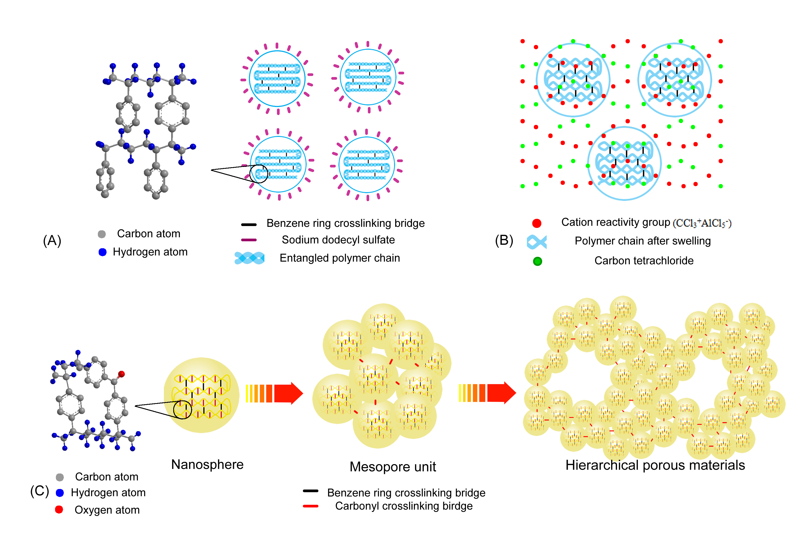
Figure 1. A scheme for preparation of hierarchical nanoporous polystyrene ( A ) copolymer nanospheres synthesize by microemulsion , structure of benzene ring as crosslinking bridge is magnify. (B) Swelling nanospheres in the reaction system. (C) schematic synthesis philosophy of HNP, structure of benzene ring and carbonyl crosslinking bridge is magnify.
As far as we know, the smallest St-DVB copolymer particle size was 250 nm ^{[19]}. Obviously, such particles are not the ideal precursor for constructing numerous mesopores (2-50nm) by linking them, and smaller particles with monodisperse must be pursued. Arming the knowledges of dispersion polymerization and delay addition method (DAM)^{[20]}, we optimize the synthesis crafts and produce smaller particles (60 nm, see Figure 2A ) successfully with lower styrene nucleation concentration ( 10% base on the total styrene ) and more stable particles growing state (30% base on the total styrene). Under the demulsification of methanol, nanospheres are separated from microemulsion and redisperse in tetrachloromethane. After swelling to the scheduled time, the Friedel-Crafts post-crosslinking reaction is induced by adding anhydrous AlCl₃. Owing to complete swelling, polymer chains are loose and exposed in solvent insteaded of entangled together tightly, the cation reactivity group (CCl₃⁺) gets the chances to encounter the inner benzene ring and form the carbonyl crosslinking bridge between the inner chains. As the post-crosslink reaction processing, the inner space is subdivided and numerous micropores are formed. Synchronously, carbonyl crosslinking bridge also emergences among outer surface of the nanospheres that had already stacked closely and orderly spontaneously, and becomes the tight junction of these nanospheres. Therefore, various configurations interrelated with natural arrangement of nanospheres, similared with the configurations of packing microspheres^{[21]}, are formed in the beginning of the reaction. For mesopores being builded up among the linking nanospheres, we name these configurations “mesopore unit” collectively. Obviously, the shape of mesopore units is omnifarious, freakish and anisomerous, all these features encumber the units to stack orderly. Therefore, once they stack closely in a certain orientation, they are linked and fixed by carbonyl as the reaction processing. At the same time macropores, among the mesopore units, emerge and the 3D interconnected hierarchical network becomes integrated gradually.
Results and discussions
The resulting diameters of nanospheres with corresponding polydispersity index ( PI ) , as calculated by dynamic light scattering ( DLS ) measurement are showed in Figure 2. It can be seen that St-DVB copolymer nanospheres in microlatexes get the size of ca. 60 nm with narrow polydispersity (PI=0.05), and the size increase to 67 nm with wider polydispersity (PI =0.11) after swelling in CCl₄ for 12 h, respectively. These results indicate that the nanospheres can keep sphericity after suffering the demulsification of methanol and disperse in CCl₄ without conglutination, and 10% degree of cross-linking is propitious to keep narrow polydispersity and strong enough to maintain the copolymer particles in CCl₄, to a acceptable extent, in sphericity. The SEM images, showed in Figure 3a reveal the morphology of nanoparticles without swelling and indicate a same situation. Just as we know, the uniform nanospheres are robust and arrange regularly with the size of ca. 60 nm, totally agree with the results shown above. Overall, swelling is just create the subspace that is subdivided in post-crosslinking step, and will not destroy the spherical shape of nanospheres.
Figure 2. Intensity size distribution of (A) St-DVB copolymer nanospheres in microlatexes and (B) particles swelling in CCl₄ for 12 h.
Scanning electron microscopy (SEM), and transmission electron microscopy (TEM) studies clearly show the uniqueness of the 3D interconnected hierarchical porous structure. The SEM image (Figure 3b) shows the morphology of post-crosslinking nanospheres. Spherical polymer gel are found throughout the span of the slide glass, which have the same size with nanospheres of ca. 60 nm and no collapse are found throughtout the dried HNP, which are typically observed in colloidal polymer as result of the volume reduction associated with shrinkage. The 3D uniformity polymer gel demonstrates the remarkable effectiveness of crosslinking bridge that not only assists in maintaining the sphericity during the reaction process, but also stabilizes the entire appearance of nanospheres in their final configuration after drying. A group of nanospheres linked together orderly, thus forming various configuration mesopore units. The diameter of the pores among nanospheres is less than 50 nm. When the mesopore units are linked in a certain orientation, wider pore with diameter of about 50-200 nm appear among them, thus forming an integrated network. The TEM image (Figure 3c) reveals the integrated network of HNP. The image seems to suggest that a strong interaction occurs at the inter-particles contacts, which leads to an enhanced network strength. A typical hierarchical configuration is magnified (Figure 3 d/e) to show the situation of forming pores by linking nanospheres and the hierarchical porous structure in HNP. The uneven color of TEM image (Figure 3 d/e) caused by difference of degreed of transmission electron beam indicates that the nanospheres are linked in 3D direction. It can be seen (Figure 3 e) that the micropores exist in spherical polymer gel diffusely, and connect with mesopores that spread around the macropores, thus forming hierarchical mass transfer channels in different length scales.
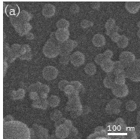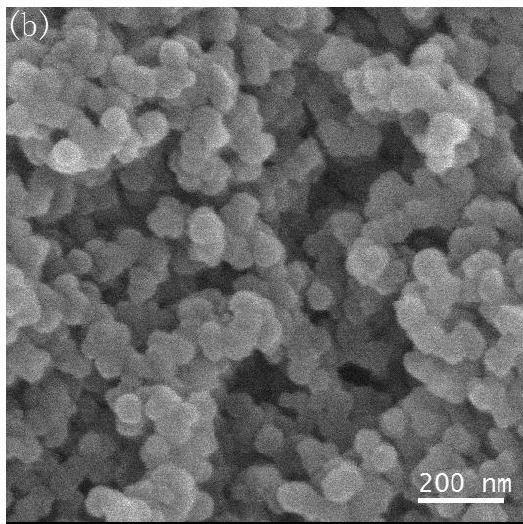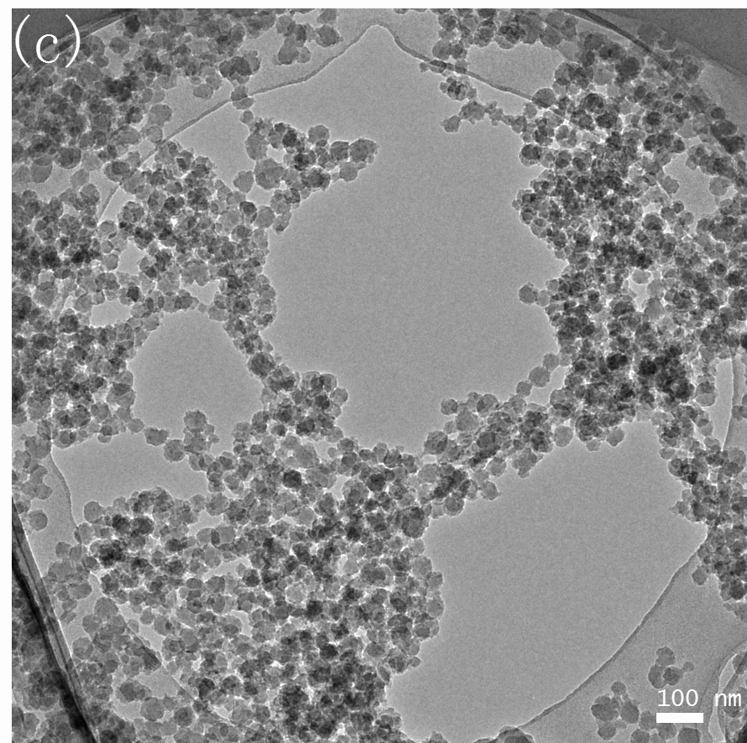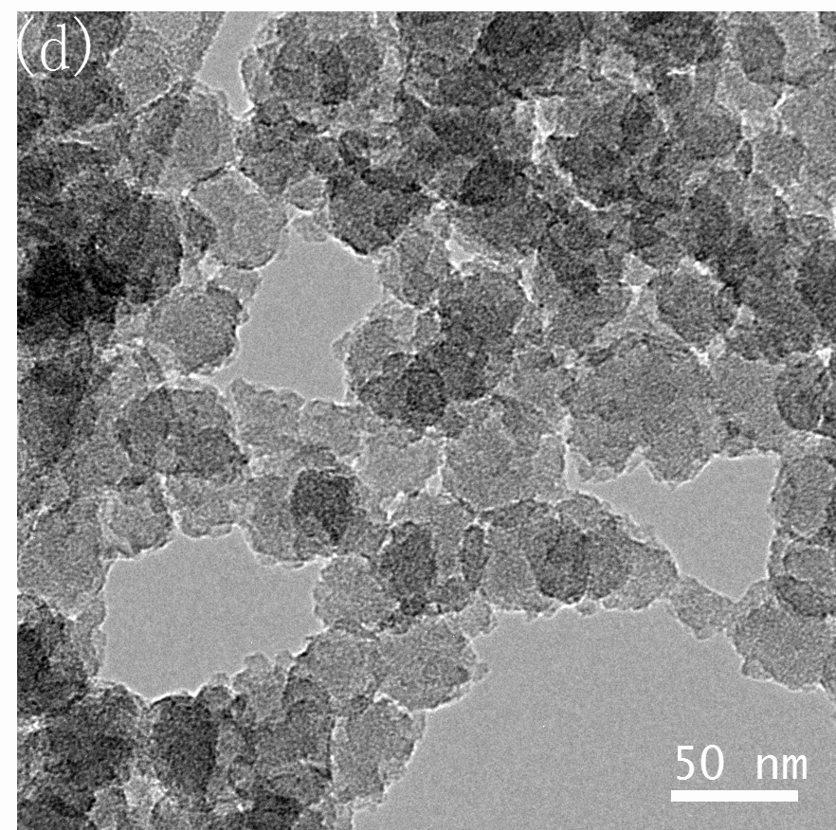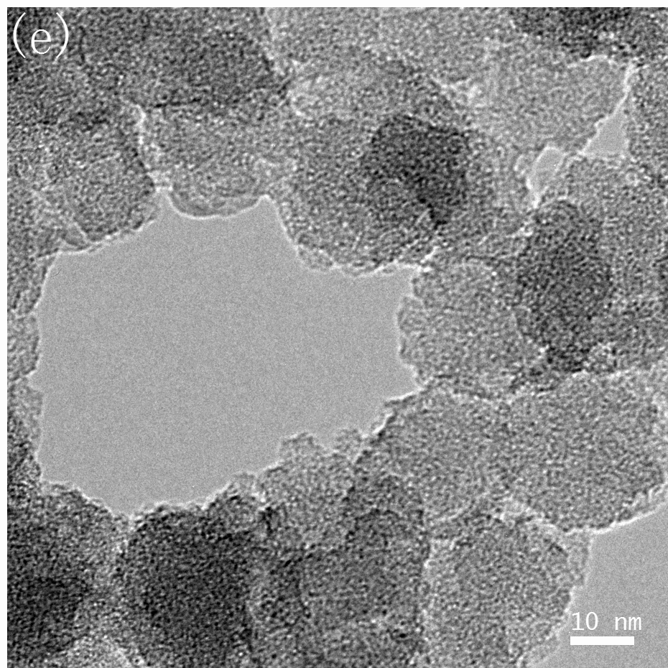
Figure 3. Micrographs of HNP. (a) SEM micrograph of nanospheres separating from emulsion. (b) SEM image showing the morphology of HNP. (c)TEM image of integrated hierarchical nano-network of HNP, and is magnified to (d) showing the situation of forming pores by linking nanospheres. (e)TEM image of hierarchical porous structure in HNP.
The SEM and TEM images have demonstrated the existence of hierarchical porosity in HNP and revealed the morphology perfectly. However, the parameter of hierarchical porous structure is unclear. In order to reveal the hierarchical porosity quantitatively, the HNP is characterized using N₂ adsorption measurements. Figure 4a shows the adsorption–desorption isotherms of HNP. The high uptake of N₂ adsorption at low relative p / p₀ clearly indicates the presence of micropore ( D < 2 nm ) and this is further supported by a positive slope in the t - plot analysis ( not shown, micropores surface area = 170 m² / g, micropore volume = 0.11 mL / g ). Type - IV isotherms and hysteresis loop at high relative p / p₀ ( > 0.4 ) express the existence of mesopore and macropore ( mesopore volume = 0.39 mL / g, macropore volume= 0.18 ml / g, t-plot external surface area= 296 m² / g ). Figure 4b shows the DFT pore size distribution curve of HNP. It was found that after post-crosslinking, nanospheres contain numerous micropores (centered at 0.7 and 1.4 nm) and interconnect in different directions into a three-dimensional nano-network, leading to the formation of large numbers of meso- and macro- pores with length scale ranging from 2 to 200 nm and having a maximum, which we thought determined by the size of nanospheres, at 40 nm .
Figure 4. (A) N₂ adsorption isotherms of HNP and (B) DFT pore size distribution of HNP
Conclusion
The template-free method of fabrication of hierarchical porous materials is proposed and a novel hierarchical nanoporous polystyrene materials with interconnected macro-meso-microporous network are prepared in the absence of auxiliary templates successfully. This method of synthesis will extend the preparation of polymer hierarchical porous materials without structure-directing agents and promote the bulk chemical applications of it.

References
[1]. P. T. Tannev, M. Chibwe, T. J. Pinnavaia, Nature. 1994, 368, 321.
[2]. S. Valkama, A. Nyänen, H. Kosonen, R. Ramani, F. Tuomisto, P. Engelhardt, G. T. Brinke, O. Ikkala, J. Ruokolainen, Adv. Funct. Mater. 2007, 17, 183.
[3]. A. Gutowska, L. Li, Y. Shin, C. M. Wang, X. S. Li, J. C. Linehan, R. S. Smith, B. D. Kay, B. schmid, W. Shaw, M. Gutowski, T. Autrey, Angew. Chem. Int. Ed. 2005, 44, 3578.
[4]. D. W. Wang, F. Li, M. Liu, G. Q. Lu, H. M. Chen, Angew. Chem. Int. Ed. 2008, 47, 373.
[5]. M. Hartmann, Angew. Chem. Int. Ed, 2004, 43, 5880.
[6]. S. Polarz, M. Antonietti, Chem. Commun. 2002, 2593.
[7]. H. -P. Hentze, M. Antonietti, Curr. Opin. Solid State Mater. Sci. 2001, 6, 343.
[8]. G. J. de Soler-Illia, C. Sanchez, B. Lebeau, J. Patarin, Chem. Rev. 2002, 102, 4093.
[9]. M. Muthukumar, C. K. Ober, E. L. Thomas, Science, 1997,277,1225
[10]. D. Zhao, J. Feng, Q. Huo, N. Melosh, G. H. Fredrickson, B. F. Chmelka, G. D. Stucky, Science. 1998, 279, 548.
[11]. T. Thurn-Albrecht, J. Schotter, G. A. Kästle, N. Emley, T. Shibauchi, L. Krusin- Elbaum, K. Guarini, C. T. Black, M. T. Tuominen, T. P. Russell, Science. 2000, 290, 2126.
[12]. Hayakawa, S. Horiuchi, Angew. Chem. Int. Ed. 2003, 42, 2285.
[13]. T. Sen, Gordon J. T. Tiddy, J. L. Casci, M. W. Anderson, Angew. Chem. Int. Ed. 2003, 42, 4649
[14]. A. Taguchi, J. H. Smatt, M. Linden, Adv. Mater. 2003, 15. 1209
[15]. E. A. Kirschhock, S. P. B. Kremer, J. Vermant, G. V. Tendeloo, P. A. Jacobs, J. A. Martens, Chem. Eur. J. 2005, 11, 4306.
[16]. S. Sa′nchez-Salcedo, J. Werner, M. Vallet- Regı′, Acta. Biomaterialia. 2008, 4, 913.
[17]. C. Li, Y. Wang, B. Shi, J. Ren, X. Liu, Y. Wang, Y. Guo, Y. L. Guo, G. Lu, Microporous Mesoporous Mater 2009, 117, 104.
[18]. A. Fischer, Y. Jun, A. Thomas, M. Antonietti, Chem. Mater. 2009, 21, 641
[19]. T. Gong, C. C. Wang, J. Mater. Sci. 2008,43,1926
[20]. J. S. Song, M. A. Winnik, Macromolecules, 2005, 38, 8300
[21].V. N. Manoharan, M. T. Elsesser, D. J. Pine, Science. 2003, 301, 483
[22]. J. Hradil, E. Králová, POLYMER, 1998, 39, 6041

新型层次孔聚苯乙烯材料的免模板法制备
曾庆聪, 邹冲, 吴丁财*，徐飞，符若文*
聚合物复合材料及功能材料教育部重点实验室，中山大学化学与化学工程学院，广州 510275
摘要：目前，层次孔材料通常采用模板法进行制备，这大大地制约了它们的工业应用进程。因此，开发无需借助任何软/硬模板的免模板法制备新工艺是发展层次孔材料的一个重要方向。本文报道一种制备新型层次孔聚苯乙烯的免模板技术。首先，优化微乳液聚合工艺，从而合成出粒径低至55 nm的单分散苯乙烯-二乙烯基苯共聚物（PS-DVB）纳米球（目前文献最低值为250 nm）；然后，利用Friedel-Crafts后交联反应，将PS-DVB纳米球连接形成具有独特层次性的三维纳米网络结构，由此构筑出新型层次孔聚苯乙烯材料（hierarchical nanoporous polystyrene, HNP）。这种HNP材料的BET表面积为466 m2/g；网络纳米球内部的微孔主要分布在0.7和1.4 nm，其比表面积为170 m2/g；纳米球后交联堆叠所形成的外部孔（即中孔和大孔）集中分布在40 nm，其比表面积为296 m2/g。DFT计算表明，微孔、中孔和大孔等各层次纳米孔的孔容分别为0.11、0.39和0.18 cm3/g。
关键词：交联纳米球 ，Friedel-Crafts后交联 ，层次孔聚苯乙烯

